UDC 004.056.55: 004.032: 004.93
SIMULATING AND RESEARCH of BLOCK PARAMETRIC MATRIX affine-permutation ciphers (BP_MAPCs) for cryptographic transformations
V.G. Krasilenko, A.A. Lazarev, D.V. Nikitovich
Vinnytsia National Technical University

In communications era, need to transmit, cryptographic transformations (CTs) specific text-graphic documents (TGDs) in form of table data, 2, 3-D arrays, drawings, diagrams, resolutions has essentially increased [1-7]. For security purposes technologies of cryptography, tools for CTs [1-7] and protocols for the formation of keys and their exchange [8, 9] are used, but only small part is devoted to methods oriented on matrix models (MM) [2, 3] and tools. The search and research of new matrix models (MM) of CT, improvement of matrix ciphers are actual task. In works [1, 2] generalized algorithms for CTs, so-called matrix affine-permutation ciphers (MAPCs) [3] based matrix affinity ciphers (MACs) [2], were proposed. The results of simulation [1-7] of CTs used such MMs have shown their significant advantages: greater stability, increase in speed. In work [2] on the basis of MACs the algorithm for creating digital blind signature (DBS) is proposed. The simulations of algorithms for creating 2D key are also known [8]. One of main components of MAPCs [3] is matrix permutation model (MM_P). Improvement of matrix-type (MT) ciphers based on MM_P is highlighted in [6, 7]. However, as shown in [4], the CTs on their basis, without additional operations, do not modify histograms of TGDs. For most of works related to MAC [1, 5], MAPCs [3] and like [2, 4, 6, 7], there is a common significant disadvantage, which requires the use of two MK. Therefore, the search to improve the multi-step MAPCs [7] while maintaining characteristics, in order to reduce the number of MKs, and their experimental verification is a urgent task. The emergence of multi-processors requires creation of matrix-algebraic models (MAM), matrix-type systems (MT) for CT. The promise of the MAM for the CT is evidenced by the ability to check the integrity of the cryptograms and expanding their functionality [6]. The generalization of the MAM to a matrix-block view is necessary in terms of the versatility. Thus, the actual purpose is development of block modifications of MAPCs with the possibility of choosing its parameters, cyclic/block keys, their simulation on information objects (IO), demonstration of their advantages. The CT algorithm for encryption based on BP_MAPCs consists of the following steps: 1) the partition of IO into blocks in the form of matrices with a dimension 2^{m}x2^{m}, where m = 4, 5, 6, ... and with element-bytes in a digital format that at m = 4 is equivalent to the length of the block 256x8 = 2024 bits; 2) the permutation of the bytes of each block using the current key (CK), which is formed synchronously from the main key by the selected procedure according to the parametric model, the argument of which is index of block, 3) matrix affine/affine-permutation transformations (MAPTs) of bytes in block using the CK, the same as on stage 2 or similar, but according to parametric model, 4) concatenation of received blocks for formation of cryptogram of IO. The decryption process has the following steps: 1) decomposing the cryptograms on blocks, 2) using MAPT for reversing of blocks based on the reversed CKs; 3) reversing the permutation of bytes of blocks by CKs; 4) concatenating the transformed blocks into the restored IO. Modeling of BP_MAPC was done with Mathcad. Windows for CT modeling by BP_MAPCs are shown in Fig. 1-5. The essence of MAPT is to apply to blocks, as set of bytes (PIC_S), procedures pixel by pixel modulo multiplication/additions by 8-bit MKs (direct/inverse), depending on the parameters, formation modules, which are shown in Fig. 2. As can be seen, the simulations of the processes of direct/inverse CT TGD, images confirm the correct operation of the models. As it was shown by researches, several iterative multiplications of data (MD) on MK Р (permutations) to may not be sufficient with the application of the same MK for TGDs. In order to improve the algorithm, we propose applying various current MKs to blocks and increasing the dimension of MK, blocks to 256x256 bytes. Thus, the idea of BP_MAP-ciphers of CTs consists in using the functional dependencies of their parameters on block indices and additional vector keys (VK). The MP in the generally accepted form should be square with N x N elements ("0" or "1"), where N = 2¹⁶. The power of the set of MPs, that is, their number is estimated as N!, which gives huge values. Each address of block can be represented using 2 bytes, indicate 2 coordinates of block. This enables to represent any permutation P by 2 blocks (256 x 256), putting in each identical address of these blocks the corresponding high byte (in first block) and the least byte (in second) the coordinates of new address of the byte for permutation. The module for generating main MK (MP), of its components KeyA, KeyB in format of 2 gray images is shown in Fig. 1.
The analysis of histograms before/after the CTs confirms that the proposed models give better results. The TGD entropy was 0.738, and the cryptogram entropy increased 10.6–10.8 times and became equal to 7.82-7.999. The entropy of cryptogram has become almost equal to 8 bits per element: 7,999 (- 0.009 %!). Without knowledge of MK it is impossible to restore MD. As was shown in [2], already with dimension of 32x32 MK (P), the stability is ensured. The power of possible keys set has increased by many orders of magnitude with dimension 256x256 8-bit elements of key (power of keys set is estimated 256² !!). Therefore, stability has increased significantly.
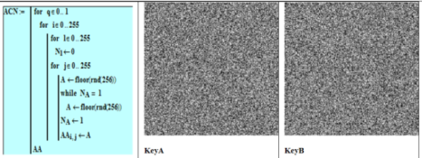
Fig. 1. The module for the generation of the head MP (KeyA and KeyB). 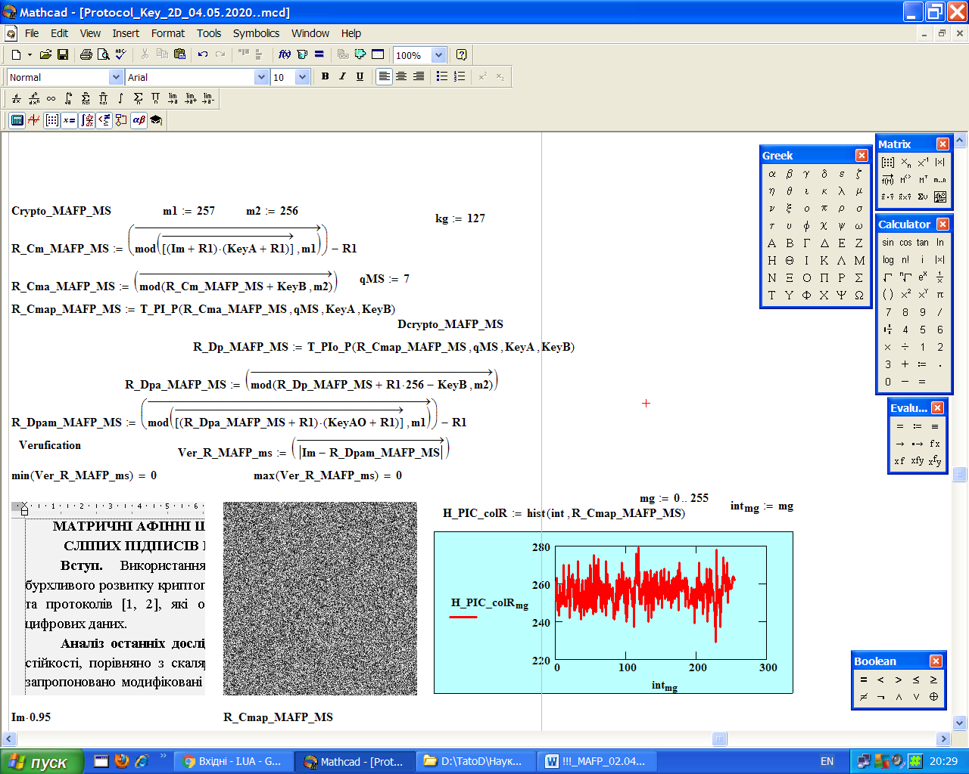
Figure 2. Mathcad window with BP_MAPC of forward/reverse CTs (pixel-by-pixel affine encryption/decryption and multiple permutations.
Figure 3. The results of cryptographic image Im conversion using BP_MAPC: the original image, cryptogram and histogram of cryptogram.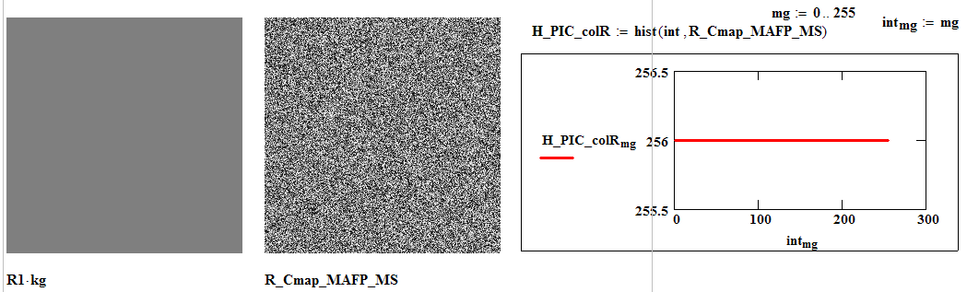
Figure 4. The results of cryptographic conversion of single-level image R1.
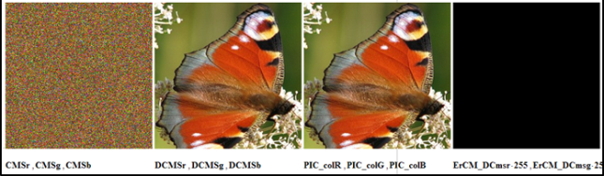
Figure 5. Forward and reverse CT color images using BP_MAPC.
For MAM, it is necessary to form a whole series of MPs from main MK (MMK). Previously considered only MMK of general type was considered. The aim of the work is to study the processes of formation of the MP flow for CTs. In [9] questions were considered of creating by the parties a secret MMK of type P with isomorphic representations and the synthesis of set number of sub-keys of a similar type from it (will be covered in the report). Conclusions. New BP_MAPC for CTs are proposed. The of their modeling are presented using direct/inverse CT, which indicates correct operation, effectiveness, advantages of ciphers with an increased permutation matrix.
Literature
- Krasilenko V.G. Modeling of Matrix Cryptographic Protection Algorithms / V.G. Krasilenko, Y.A. Flavitskaya // Bulletin "Computer Systems and Networks". - 2009. - No. 658. - pp. 59-63.
- Krasilenko V.G., Matrix Affine Ciphers for the Creation of Digital Blind Signatures for Text-Graphic Documents / V.G. Krasilenko, S.K. Grabovlyak // Systems of information processing. - Kh.: KhUPPS, 2011. - Vol. 7 (97). - pp. 60 - 63.
- Krasilenko V.G. Matrix affine and permutation ciphers for encryption and decryption of images / V.G Krasilenko, S.K. Grabovlyak // Systems of information processing. - Kh., 2012. - Vo. 3 (101). - t. 2. - pp. 53-62.
- Krasilenko V.G. Cryptographic transformations of images based on matrix models of permutations with matrix-bit-map decomposition and their modeling / V.G. Krasilenko, V.M. Dubchak // Bulletin of Khm. National University. Technical sciences. - 2014. - No. 1. - pp. 74-79.
- Krasilenko, V.G. Modeling of Matrix Affine Algorithms for the Encryption of Color Images / V.G. Krasilenko, K.V. Ogorodnik, Yu.A. Flavitskaya // Computer technologies: science and education: abstracts of reports v VseUkr. sci. conf. - K., 2010. - pp. 120-124.
- Krasilenko V.G. Modeling and research of cryptographic transformations of images based on their matrix-bit-map decomposition and matrix models of permutations with verification of integrity / V.G. Krasilenko, D.V. Nikitovich // Electronics and Information Technologies. - Lviv: National University, 2016. - Vo. 6. – pp. 111-127.
- Krasilenko V.G. Simulation of cryptographic transformations of color images based on matrix models of permutations with spectral and bit-map decompositions / V.G. Krasilenko, D.V. Nikitovich // Computer-integrated technologies: education, science, production: sciences, - Lutsk: Lutsk Nat Tech Un., - 2016. - No. 23. - pp. 31-36.
- Krasilenko V.G. Modeling Protocols for Matching a Secret Matrix Key for Cryptographic Transformations and Matrix-type Systems / V.G. Krasilenko, D.V. Nikitovich // Systems of information processing. - 2017 - Vo. 3 (149). – pp. 151-157.
9. Krasilenko VG Modeling of methods for generating flows of matrix permutations of significant dimension for cryptographic transformations of images // V.G. Krasilenko, D.V. Nikitovich // Abstracts of the II All-Ukrainian STC Computer Technologies: Innovations, Problems, Solutions. - Zhytomyr: Zhytomyr Polytechnic, 2019. - P. 67-77.

