Study of multicomponent soil contamination around the landfills of
solid municipal waste

O.V. Berezyuk¹, V.I. Savulyak¹, G.S. Kalda²

1 Vinnytsia National Technical University, Ukraine
2Khmelnytskyi National University, Ukraine
E-mail: berezyukoleg@i.ua

Abstract
The article deals with the determination of the regularity of the level dimensions of the zones of multicomponent contamination ( by heavy metals and petroleum products) of the soils adjacent to the landfill of solid municipal waste. The dependences of the concentrations of mercury, copper and zinc in the soil on the distance to the solid municipal waste landfill were determined, similar dependence was specified for petroleum products for a distance of up to 500 m. The method of regression analysis of the results of single-factor experiments and other paired regularities was used to perform the study by choosing more adequate type of function from the most commonly used options according to the criterion of the maximum value of the correlation coefficient. Regressions were carried out on the basis of linearizing transformations, which allow to reduce the non-linear regularity to a linear one. Graphical dependences, describing the change in the concentrations of individual soil pollutants with the distance from the landfill of solid municipal waste have been built, they enable to show the sufficient convergence of the theoretical results with actual ones. The regularity of the level of multicomponent soil contamination (with heavy metals and petroleum products) at the distance from the landfill of solid municipal waste has been obtained, it is required for determining the dimentions of the zones of multicomponent soil contamination . Applying the method of iterations, the dimensions of the zones of multicomponent contamination (with heavy metals and petroleum products) of the soils, adjacent to the landfill of solid municipal waste have been determined: very heavy pollution - 22.93 m, heavy pollution - 81.77 m, average pollution - 474.9 m from the foot of the landfill.

Key words: ecology, multicomponent contamination, soil pollution, heavy metals, petroleum products, landfill, municipal solid waste, iteration.

Introduction

Municipal solid waste (MSW) [1], which is a heterogeneous multicomponent mixture of complex morphological composition, has a significant negative long-term impact on human health and the environment unlike еру construction or industrial waste [2, 3], which is basically, homogeneous and relatively easy to be further processed. On the territory of Ukraine, the annual volume of solid waste formation exceeds 54 million m³, the greater part of this volume is buried in 6,107 landfills and dumpsites , their total area is almost 7,700 hectares and only minor part of the waste is partially recycled or disposed at the incineration plants, unlike highly developed countries, where modern recycling and disposal technologies are used [4]. During the period of 1999-2014, the total area of landfills and dumpsites in Ukraine tripled. The area of the overloaded landfills and dumpsites, where environmental safety standards are violated , creating a threat of the environmental pollution, in particular, chemical pollution of soil with heavy metals and petroleum products which are the constituent parts of the waste or are the products of its decomposition and negatively affect physical, chemical and biological properties of the soil, cause diseases of living organisms [5], pollution of the adjacent land plots [6], exclusion of the fertile soils from the agricultural production. Therefore, solid waste management is one of the most acute environmental problems of the mankind.
According to the Decree of the Cabinet of Ministers of Ukraine No. 265, the provision of the control over the operating and closed solid municipal waste landfills to prevent harmful impact on the environment and human health is among the priority directions of solid waste management in Ukraine [7]. That is why, establishing the dependences of the concentrations of individual pollutants (heavy metals and petroleum products) on the distance to the SMW disposal site in order to determine the regularity of the level and dimensions of the multicomponent pollution zones of these soils is an urgent scientific and technical task.
Analysis of the recent research and publications

The environmental hazard assessment of the Novoyavoriv landfill in Lviv Region of Ukraine, located on the border with Poland, was carried out in the study [6], in particular, the content of chlorides and sulfates in the soils around the landfill was determined by quantitative and qualitative methods. It was found that the content of chlorides and sulfates is different in different areas of the landfill. The most polluted areas are at a distance of 10 m and 50 m from the foot of the landfill. At a distance of 100 m from the landfill, the concentration of chlorides decreases to 0.001% (at a depth of 5 cm) and 0.1% (at a depth of 10...20 cm). High sulfate content of 1% is observed at a distance of 10 m from the foot of the landfill (at a depth of 10...20 cm).
In the paper [8], the impact of the soil pollution with petroleum products, such as gasoline, diesel fuel, and used motor oil, on plant growth was determined. It was established that within five years after the contamination, petroleum products negatively affect plant growth due to a significant increase in peroxidase activity and increase of the proline content, as well as the decrease of the nutrients (Ca, Mg and P) content in plants. Diesel fuel reduced the content of K and N, whereas used motor oil reduced Fe. Petroleum products also increased the content of lead and cadmium, and some of them caused the decrease of the content of zinc, manganese and copper. This mutual influence stipulates the need to study the multicomponent contamination of soils with heavy metals and petroleum products.
The materials of the article [9] present the results of the analysis of heavy metals concentrationin in the fine fraction of solid municipal waste and soil samples collected around the open dump site of solid waste in Ariyamangalam, Tiruchirappalli District, Tamil Nadu State (India). The concentration of heavy metals in the collected soil sample was determined in the following order: Mn > Pb > Cu > Cd. The presence of heavy metals in the soil sample indicates significant soil contamination by leachate migration from the open dumpsite . It has been established that these types of contaminants will continuously migrate and seep through the soil layers, and in a particular period of time they can contaminate the groundwater system if measures are not taken to prevent this phenomenon.
The levels of soil contamination with some heavy metals near the municipal solid waste dump site in order to provide the information on the degree of contamination, the ecological risk of metals in the soil, health risk for the residents of the city of Uyo (Nigeria) are investigated in [10]. Soil samples were taken in the rainy and dry seasons and analyzed for the content of metals (Pb, Cd, Zn, Mn, Cr, Ni and Fe) using the method of atomic absorption spectrometry. Concentrations of heavy metals (mg/kg) at the dampsite in the rainy season were Pb (9.90), Zn (137), Ni (12.56), Cr (3.60), Cd (9.05) and Mn (94 .00), while in the dry season the concentrations were Pb (11.80), Zn (146), Ni (11.82), Cr (4.05), Cd (12.20) and Mn (91.20 ). Studies of contamination indices showed that soil samples from the dampsite and at a distance of 10...20 m to the east of the dampsite were heavily contaminated with cadmium. The environmental risk assessment has shown that cadmium accounts for 98-99% of the total potential environmental risk. Probable health risk was not observed, as the total hazard index of all the metals was less than one. However, it turned out that children are more susceptible to heavy metals pollution than the adults.
In the paper [11], the assessment of the environmental risk and factors of the heavy metals impact on the soils of the solid municipal waste landfills was carried out by reviewing the literature, field studies and statistical methods. The results showed that the dominant heavy metal pollution in the soil at the SMW was caused by chromium Cr with Nemerow Pollution Index (NPI) values from 22.7 to 44.3 and zinc Zn with NPI values from 0.7 to 9.8. There were significant differences in Cr, Hg, Pb, Zn, and arsenic As concentrations between soil samples from sanitary and nonsanitary landfills, where heavy metal contamination was more evident.
The authors of the paper [12] conducted the analysis of the multielement soil contamination with heavy metals and metalloids of the soil around the solid municipal waste landfill according to the following criteria: maximum admissible concentration coefficient, concentration coefficient, aggregate concentration coefficient . Сalculation of the total pollution index of the soil was carried out based on the complex of all analyzed indices . Heavy and very heavy soil contamination was most evident for Cd and Pb at a distance of up to 600 m. However, at the same time, heavy soil contamination was noted only in the individual samples for Zn and Cu or was not recorded at all (for Ni).
The analysis of the heavy metals content in the surface soils collected from 15 solid municipal waste landfills in the city of Kinshasa (Democratic Republic of Congo) was carried out in the article [13]. The average concentration of heavy metals in all soil samples was determined in the following order: Zn > Pb > Cu > Cr > Co > Cd > As > Hg. The calculated pollution indices, including geoaccumulation, enrichment factor, degree of pollution and potential environmental risk, showed polymetallic pollution predominating for several of these metals, of which Zn, Cu, Pb and Hg are of greatest concern due to high environmental risks.
Experimental data regarding the concentration of the heavy metals (lead Pb, mercury Hg, copper Cu, zinc Zn) and petroleum products in the soil at a distance of 0...500 m from the solid municipal waste landfill are presented in [14]. In the materials of the article [15], using the method of regression analysis, the dependence of the lead concentration in the soils on the distance (0...500 m) to the solid waste landfill was determined, it can be used for the construction of the the regularity of multicomponent contamination level of these soils
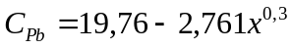 [мг/кг], (1)
where CPb is the concentration of lead in the soil, mg/kg;
x –is the distance to the landfill, m.
The author of the paper [16] obtained the dependence of the petroleum products concentration in soils at a distance of 0...200 m from the landfill site, but it requires clarification before its usage for the construction of the the regularity of the level of multicomponent pollution of these soils at a distance of 0...500 m. The authors did not find any mathematical regularities describing the dependences of mercury, copper, zinc concentration in the soil on the distance to the landfill site.

Aim of the paper

The aim of this paper is to establish the dependence of the concentrations of individual pollutants (heavy metals and petroleum products) on the distance to the SMW disposal site in order to determine the regularity of the level and dimentions of the multicomponent pollution zones of these soils.

Research methods

The determination of the paired dependences of the concentrations of individual soil pollutants on the distance to the SMW disposal site was carried out applying the method of regression analysis [17]. Regressions were determined on the basis of linearizing transformations, which allow to reduce the non-linear regularity to a linear one. The coefficients of the regression equations were determined by the method of least squares using the developed computer program "RegAnalyz", which is protected by the Certificate of the State Registration of the rights to the copyright object and is described in details in the work [18].
Determination of the regularity of the level of multicomponent soil contamination around the solid municipal waste landfill was carried out according to a general index that takes into account all pollutants,--- aggregate coefficient of the complex pollution, determined by the formula [19]:
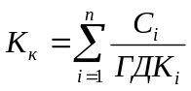, (2)

where K_{k----} is the aggregate coefficient of the complex pollution;
C_{i} –is the concentration of the ith soil pollutant, mg/kg;
MPC_{i} --is maximum permissible concentration of the i-th soil pollutant, mg/kg;
n-- is the number of pollutants.
Zoning of multicomponent soil contamination around the solid municipal waste landfill was carried out on the basis of the values of the aggregate coefficient of the omplex pollution according to the Table. 1.

Table 1

Zoning of the multicomponent soil contamination [20]

Zones of soil contaminatin | Aggregate coefficient of the complex pollution Kk | Possible use of agricultural soils [21]
uncontaminated | < 0,5 | Can be used for any crops
slightly polluted | 0,5...1,5 | Can be used for any crops
moderately polluted | 1,5...2 | Can be used for any crops, under conditions of quality control of crop production
heavily polluted | 2...2,5 | Can be used for the industrial crops without obtaining food and fodders from them
very heavily polluted | > 2,5 | Exclude from the agricultural use

The dimentions of the multicomponent soil contamination zones around the SMW disposal site were determined by the method of iterations [22] in the MathCAD environment, using the formula, obtained on the basis of the regularity (2), paired dependences of the concentrations of individual soil pollutants and their MPC.

Obtained results of the research

Table 2 shows the concentrations of heavy metals and petroleum products in the soil around the solid municipal waste landfill in the village of Sencha, Lohvytsky District, Poltava Region of Ukraine, obtained by atomic absorption method, using the atomic absorption spectrophotometer of C-115 Y type [14]. Also Table 2 presents the maximum permissible concentrations (MPC) in the soil of the specified chemical substances in accordance with the Hygienic Regulations [23].
Based on the data in the Table 2, it was planned to obtain mathematical models in the form of paired regression dependences of the concentrations of individual pollutants (heavy metals and petroleum products) in the soil on the distance to the SMW disposal site.

Table 2

Concentrations of heavy metals and petroleum products in the soils around the solid waste disposal site [14]
Distance to the landfill of SMW, m, , | Concentrations of soil pollutants, mg/kg
Distance to the landfill of SMW, m, , | Lead Pb | Mercury Hg | Copper Cu | Zinc Zn | petroleum products
0 | 18,65 | 0,5 | 2,45 | 18,63 | 1500
50 | 12,56 | 0,1 | 1,46 | 11,46 | 1100
100 | 11,65 | 0,1 | 1,44 | 11,98 | 798
200 | 2,66 | 0,1 | 1,63 | 11,65 | 264
500 | 2,01 | 0,1 | 2,01 | 12,13 | 201
MPC in soil [22], mg/kg | 32 | 2,1 | 3 | 23 | 1000

The results of the regression analysis are shown in the Table 3, where cells with the maximum values of the correlation coefficients R for each paired dependence are marked in grey color.

Table 3
Results of the regression analysis of the concentrations of heavy metals and petroleum products in the soils around the solid waste disposal site (own data)

№ | Type of regression | Correlation coefficient R
№ | Type of regression | C_{Hg} = f(x) | C_{Cu} = f(x) | C_{Zn} = f(x) | C_{PP} = f(x)
1 | y = a + bx | 0,47816 | 0,05759 | 0,42228 | 0,83877
2 | y = 1 / (a + bx) | 0,47816 | 0,17852 | 0,38929 | 0,93673
3 | y = a + b / x | 1,00000 | 0,84700 | 0,98627 | 0,73559
4 | y = x / (a + bx) | 0,99999 | 0,99407 | 0,98985 | 0,92958
5 | y = ab^{x} | 0,47816 | 0,12005 | 0,40709 | 0,89781
6 | y = ae^{bx} | 0,47816 | 0,12005 | 0,40709 | 0,89781
7 | y = a ·10^{bx} | 0,47816 | 0,12005 | 0,40709 | 0,89781
8 | y = 1 / (a + be^{-x}) | 0,99999 | 0,77300 | 0,99078 | 0,47575
9 | y = ax^{b} | 0,98746 | 0,71478 | 0,96904 | 0,59076
10 | y = a + b·lg x | 0,98746 | 0,75872 | 0,97388 | 0,73611
11 | y = a + b·ln x | 0,98746 | 0,75872 | 0,97388 | 0,73679
12 | y = a / (b + x) | 0,47816 | 0,17852 | 0,38929 | 0,93672
13 | y = ax / (b + x) | 0,99999 | 0,77300 | 0,99078 | 0,47576
14 | y = ae^{b / x} | 0,99999 | 0,81095 | 0,99403 | 0,59013
15 | y = a ·10^{b / x} | 0,99999 | 0,81095 | 0,99403 | 0,59013
16 | y = a + bx^{n} | 0,31570 | 0,22699 | 0,25668 | 0,68462
17 | y = a + bx + с·ln x | 0,98746 | 0,99732 | 0,99596 | 0,73679

Consequently, according to the results of the regression analysis based on the data in the Table 2, the following regression models were finally approved as the most adequate:

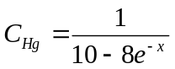 [mg/kg]; (3)
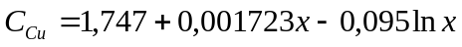 [mg/kg]; (4)
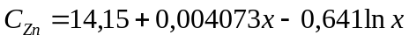 mg/kg]; (5)
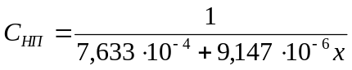 [mg/mg], (6)
where C_{Hg}, C_{Cu}, C_{Zn}, C_{PP} – is the concentration of mercury, copper, zinc, petroleum products in the soil, respectively, mg/kg;
x –is the distance to the solid municipal waste disposal site, m.
Fig. 1 shows graphical dependences, describing the change in the concentrations of individual soil pollutants with the distance from the SMW disposal site, constructed using regression equations (3-6), which confirm the previously determined sufficient convergence of the obtained theoretical dependences, compared with the data, presented in [14].

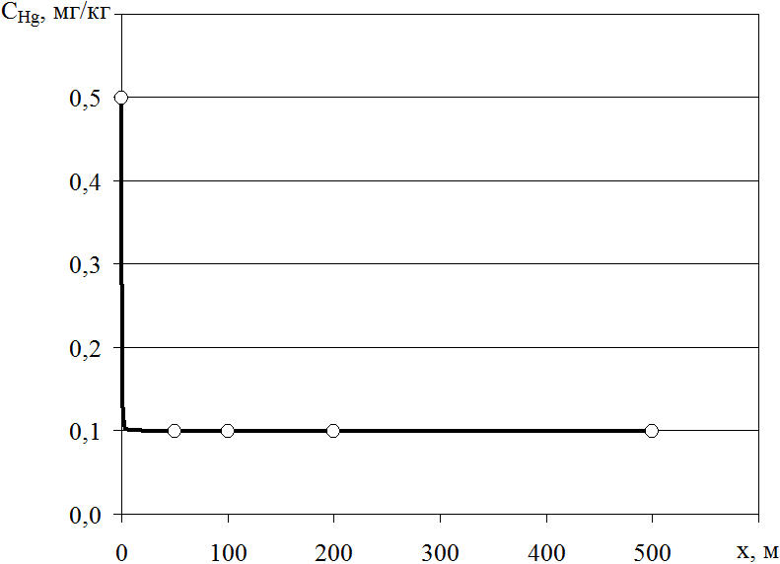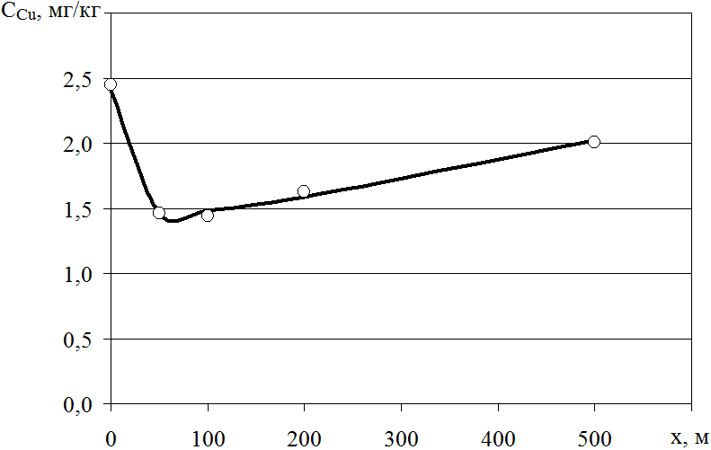
a) b)
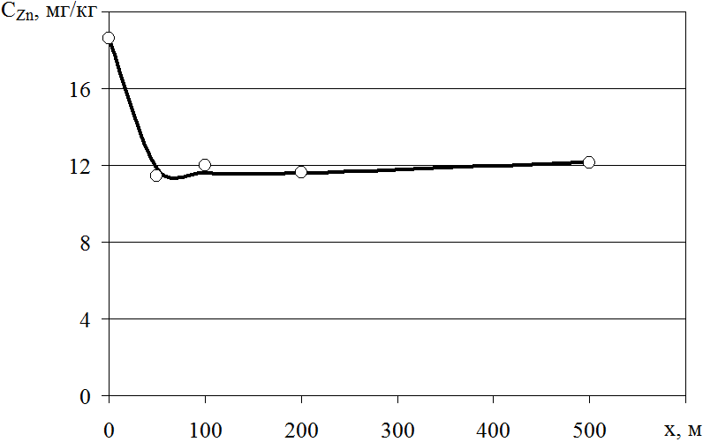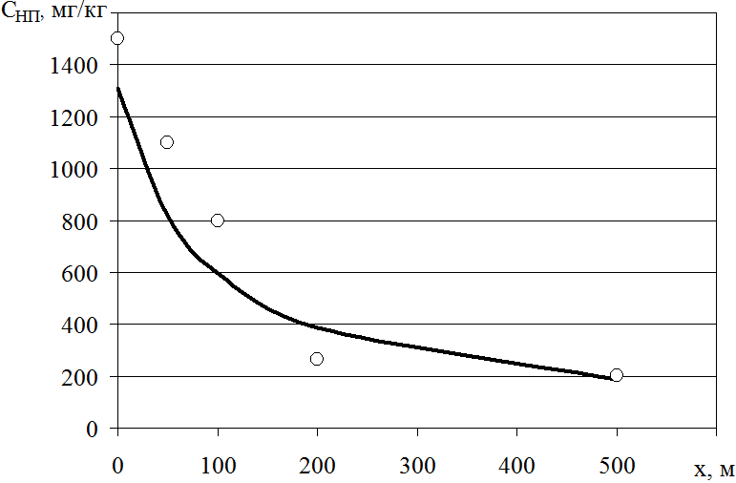

Fig. 1. Dependencies, describing the actual (○ data of the authors of the paper [14]) and theoretical (— own data) changes in the concentrations of individual soil pollutants with distance from the SMW disposal site: a) C_{Hg} = f(x), b) C_{Cu} = f( x), c) C_{Zn} = f(x), d) C_{PP} = f(x)

After substituting dependencies (1, 3-6) and MPC values for each of the pollutants into the formula (2), we will obtain the regularity of the level of multicomponent soil contamination around the solid municipal waste disposal site

. (7)
Based on the regularity (7), we will obtain the iterative formula for determining the dimentions of the zones of multicomponent soil contamination around the SMW disposal site

(8)

Using the iterative formula (8), at Kk = 2.5 and the initial value of x0 = 20 m, after the 11th iteration, we will obtain the size of the zone of very heavy multicomponent soil contamination around the solid municipal waste disposal site of 22.93 m, at Kk = 2 and the initial value of x0 = 80 m, after the 6th iteration, we will get the size of the zone of heavy multicomponent contamination - 81.77 m, at Kk = 1.5 and the initial value of x0 = 480 m, after the 13th iteration, we will get the size of the zone of medium multicomponent contamination - 474.9 m from the foot of the landfill.
Fig. 2 shows the graphic dependence describing the change in the level of the multicomponent soil contamination with distance from the SMW disposal site, built using the regularity (7), which enables to visually illustrate the given dependence. Fig. 2 shows the zones of multicomponent contamination (heavy metals and petroleum products) of the soils around the SMW disposal site.

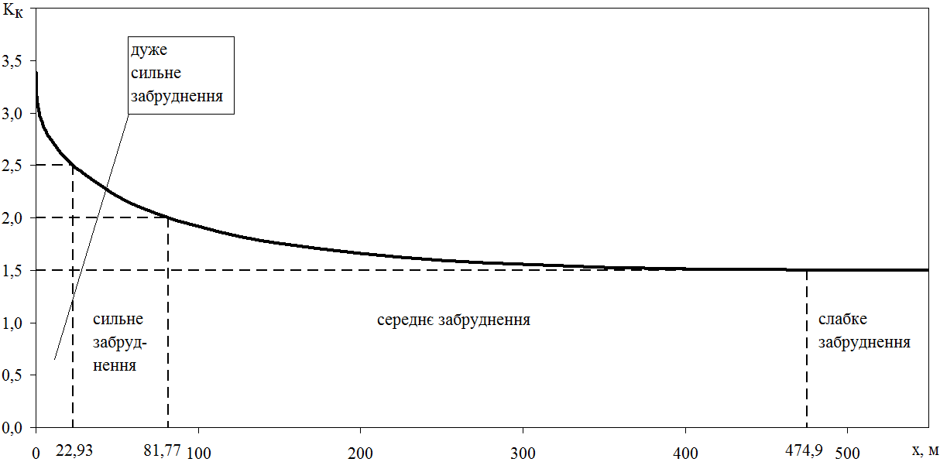
Fig. 2. Dependency describing the change in the level of multicomponent contamination (heavy metals and petroleum products) of soils with the distance from the SMW disposal site (own data)

It is seen from Fig. 2, that at the distance from the SMW disposal site from 0 to 500 m, the level of multicomponent contamination ( with heavy metals and petroleum products) of the adjacent soils decreases from 3.4 to 1.5.

Conclusions

Method of regression analysis was used to determine the dependence of mercury, copper, and zinc concentrations in the soil on the distance to the solid municipal waste landfill, the authors(WE) also specified the similar dependence for the petroleum products for the distance of up to 500 m, that was used to determine the regularity of the level and dimensions of the multicomponent pollution zones of these soils .
Graphic dependences, describing the change in the concentrations of individual soil pollutants with the distance from the solid municipal waste disposal site were constructed , they enable to visually illustrate these dependencies and show sufficient convergence of the theoretical results with actual ones.
Authors(WE) have obtained the regularity of the level of the multicomponent soil contamination (with heavy metals and petroleum products) when moving away from the landfill of solid municipal waste, which is necessary for determining the dimensions of the zones of multicomponent soil contamination.
The dimensions of the zones of multicomponent pollution (with heavy metals and oil products) of the soils, adjacent to the landfill of solid municipal waste were determined : very heavy polluted - 22.93 m, heavily polluted - 81.77 m, moderately polluted - 474.9 m from the foot of the landfill, these data are expedient to use for the return of a part of moderately polluted agricultural lands into circulation, in particular: moderately polluted soils can be used for any crops subject to quality control of crop production, and heavily polluted can be used for technical crops without obtaining food and fodder from them.

References 1. Hamer G. (2003) Solid waste treatment and disposal: effects on public health and environmental safety. Biotechnology advances, Vol. 22, No. 1-2, 71-79, https://doi.org/10.1016/j.biotechadv.2003.08.007
2. Synyuk O., Musiał J., Zlotenko B., Kulik T. (2020) Development of equipment for injection molding of polymer products filled with recycled polymer waste. Polymers, 12(11), 1-20, 2725, https://doi.org/10.3390/polym12112725
3. Skliar V., Krusir G., Iryne K., Zakharchuk V., Malovanyy M. (2020) Study of the physical and chemical characteristics of an immobilized lipase in the hydrolysis of fat waste. Ecological Questions, 31(3), 25-30, https://doi.org/10.12775/EQ.2020.019
4. US Environmental Protection Agency (2017) Municipal solid waste in the United States: 2017 facts and figures, 168.
5. Huliaieva H.B., Tokovenko I.P., Pasichnyk L.A., Patyka V.P., Horbatiuk S.M. (2021) Microbial status of rhizosphere of galega orientalis plants infected with phytopathogens and treated with nanochelates. Mikrobiolohichnyi Zhurnal, 83(5), 42-50, https://doi.org/10.15407/microbiolj83.05.042
6. Popovych V., Stepova K., Prydatko O. (2018) Environmental hazard of Novoyavorivsk municipal landfill. MATEC Web of Conferences, vol. 247, no. 25, 1-8, https://doi.org/10.1051/matecconf/201824700025
7. Cabinet of Ministers of Ukraine (2004). Resolution No. 265 "On Approval of the Solid Household Waste Management Program", URL: http://zakon1.rada.gov.ua/laws/show/265-2004-%D0%BF
8. Gospodarek J., Rusin M., Kandziora-Ciupa M., Nadgórska-Socha A. (2021). The subsequent effects of soil pollution by petroleum products and its bioremediation on the antioxidant response and content of elements in Vicia faba plants. Energies, 14(22), 7748, https://doi.org/10.3390/en14227748
9. Kanmani S., Gandhimathi R. (2013) Assessment of heavy metal contamination in soil due to leachate migration from an open dumping site. Applied water science, 3, 193-205, https://doi.org/10.1007/s13201-012-0072-z
10. Ihedioha J.N., Ukoha P.O., Ekere N.R. (2017) Ecological and human health risk assessment of heavy metal contamination in soil of a municipal solid waste dump in Uyo, Nigeria. Environmental geochemistry and health, 39, 497-515, https://doi.org/10.1007/s10653-016-9830-4
11. Wang S., Han Z., Wang J., He X., Zhou Z., Hu X. (2022) Environmental risk assessment and factors influencing heavy metal concentrations in the soil of municipal solid waste landfills. Waste Management, 139, 330-340, https://doi.org/10.1016/j.wasman.2021.11.036
12. Blokhina T. K., Karpenko O.A. (2019). Heavy metals pollution of a solid waste landfill. In E3S Web of Conferences, 116, 00010, https://doi.org/10.1051/e3sconf/201911600010
13. Mavakala B.K., Sivalingam P., Laffite A., Mulaji C.K., Giuliani G., Mpiana P. T., Poté J. (2022) Evaluation of heavy metal content and potential ecological risks in soil samples from wild solid waste dumpsites in developing country under tropical conditions. Environmental Challenges, 7, 100461, https://doi.org/10.1016/j.envc.2022.100461.
14. Pisarenko P.V., Samoilik M. S., Halytska M.A., Tsova Yu.A. (2022) Typology of technogenically disturbed lands that are under solid waste dumps, taking into account local features. Agricultural innovations, 13, 113-120.
15. Bereziuk O.V., Lemeshev M.S. Dudar I.N. (2022) Regression analysis of lead concentration in soils at a distance from solid household waste landfills. Scientific works of the Vinnytsia National Technical University, 4, 6, URL: https://praci.vntu.edu.ua/index.php/praci/article/view/665/627
16. Bereziuk O.V. (2022) Regression analysis of the concentration of petroleum products in the soils of solid municipal waste landfills. Scientific works of Vinnytsia National Technical University, 3, 6, URL: https://praci.vntu.edu.ua/index.php/praci/article/view/658/622.
17. Chatterjee S., Hadi A.S. (2015) Regression analysis by example. John Wiley & Sons.
18. Bereziuk O.V., Lemeshev M.S., Bogachuk V.V., Akselrod R.B., Vinnichuk A.P., Smolarz A., Arshidinova M., Kulakova O. (2021) Increasing the Efficiency of Municipal Solid Waste Pre-processing Technology to Reduce Its Water Permeability. Biomass as Raw Material for the Production of Biofuels and Chemicals: collective monograph. London: Routledge, 33-41, https://doi.org/10.1201/9781003177593-4
19. Mykhailiv V., Krykhivskyi M. (2022) City soil pollution research on the example of Ivano-Frankivsk. SWorldJournal, 15-01, 84-91. https://doi.org/10.30888/2663-5712.2022-15-01-023
20. DSTU 4362:2004 (2005) Soil quality. Indicators of soil fertility. Kyiv, Derzhspozhyvstandard of Ukraine.
21. Floria L.V. (2012) Assessment of the level of soil pollution by heavy metals and their impact on crop yields in the North-Western Black Sea region. Bulletin of Odessa State Ecological University, 13, 131-141.
22. Hageman L.A., Young D.M. (2012). Applied iterative methods. Courier Corporation.
23. Order of the Ministry of Health of Ukraine dated 14.07.2020 No 1595 "On approval of hygienic regulations for the permissible content of chemicals in the soil".

Дуже сильне забруднення====Very heavy pollution
Сильне забруднення------heavy pollution
Ceредне забрудн------average pollution
Cлабке----weak pollution
Authors( WE)---виберіть те що потрібно

