УДК 004.932.2

Rudnytska T.H.
Teacher of Foreign Languages
Department, VNTU
Lupyak D.D.,
Undergraduate of VNTU

GRAPH BASED METHODS FOR IMAGE SEGMENTATION

Image segmentation is the most precarious means in image processing and analysis. Basically segmentation consequences influence all the subsequent processes of image analysis such as object description and illustration, characteristic dimension, and even the subsequent higher level tasks such as classification of object. Hence, image segmentation is the most important and critical process for assisting the depiction, delineation and visualization of regions of interest in any image. Physical segmentation of an image is not only a tiresome and time consuming process, but also not exceptionally accurate particularly with the increasing imaging modalities and uncontrollable quantity of images that need to be observed. Therefore it becomes essential to examine current methodologies of image segmentation using computerized algorithms that are precise and entail as little user interaction as possible. In the image segmentation process the anatomical organization or the region of interest needs to be defined and extracted out so that it can be viewed independently. One of the most relative and general methods of image segmentation is graph based methods, having the weaknesses and strengths according to appropriateness for image segmentation applications [1].
Graph based methods for image segmentation have several good features in practical applications. They explicitly organize the image elements into mathematically sound structures and make the formulation of the problem more flexible and the computation more efficient [2].
Let $G = (V, E)$ be a graph where $V =\{ v_{1} ,..., v_{n} \}$ is a set of vertices corresponding to the image elements, which might represent pixels or regions in the Euclidean space. $E$ is a set of edges connecting certain pairs of neighboring vertices. Each edge $(v_{i},v_{j})∈ E$ has a corresponding weight$w(v_{i},v_{j})$which measures a certain quantity based on the property between the two vertices connected by that edge. In the case of image segmentation, the elements in $V$ are pixels and the weight of an edge is some measure of the dissimilarity between the two pixels connected by that edge (e.g., the difference in intensity, color, motion, location or some other local attribute).
An image can be partitioned into mutually exclusive components so that each component $A$is a connected graph $G=(V, E),$ where $V'⊆V, E'⊆E$ and $E'$ contains only edges built from the nodes of $V'$. In other words, nonempty sets $A1, …, Ak$ form a partition of the $G$ if $A_{i}∩A_{j}=φ(i,j∈\{1, 2,…,k\}, i≠j)$ and $A_{1}∪…∪A_{k}=G$.
The graph based methods are categorized into five classes : the minimal spanning tree based methods, graph cut based methods with cost functions, graph cut based methods on Markov random field models, the shortest path based methods and the other methods that do not belong to any of these classes [2].
Among the available techniques graph cut methods are widely used. Using the definition of graph theory, the degree of dissimilarity between two components can be computed in the form of a graph cut. Graph cut formalism is well suited for segmentation of images. [3]. A cut is a subset of edges by which the graph $G$ will be partitioned into two disjoint sets $A$ and $B$ and the cut value is usually defined as:
$$cut\left(A,B\right)=\sum_{U∈A, V∈B}{W\left(U,V\right),}$$
where $U$ and $V$ refer to the vertices in the two different components. The cost function is defined in terms of boundary and region properties of the segments. These properties can be viewed as soft constraints for segmentation.

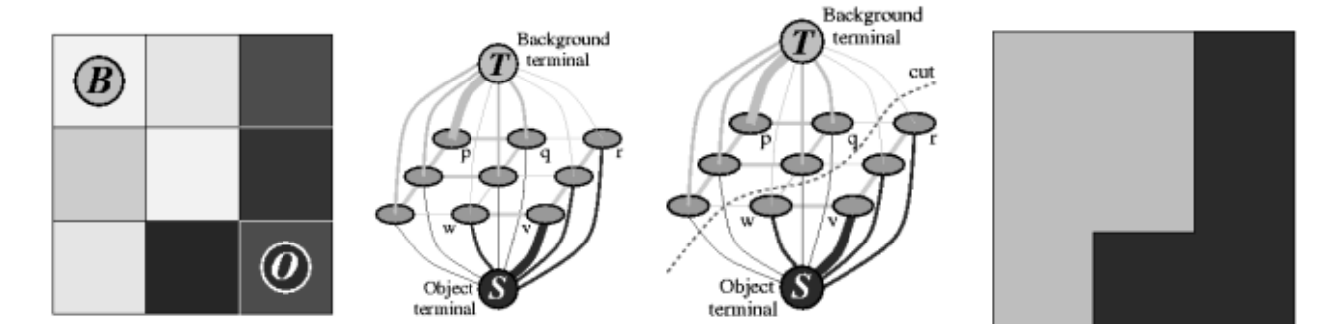
Figure 1: Graph cut
Consider an image as shown in the above fig. 1(a). Using the object and background seeds create a graph with two terminals as shown in 1(b) and by using the edge weights, boundary terms of cost function and positions of seeds in the image separate two terminals by computing optimal minimum cut 1(c). This cut would give the segmentation result as shown in 1(d). There are various methods that are used to obtain desired image segmentation using the graph theory. The advantage of the segmentation using a graph based approach is that it might require no discretization by virtue of purely combinatorial operators and thus incur no discretization errors.
Thus, it is possible to upgrade most of the algorithms by their parallelization, to improve their performance. Using interaction in image segmentation will increase their quality and segmentation accuracy, as a computer doesn't know, what segments and in what quantity a user needs.
Before using segmentation algorithm, in the process of image segmentation it is advisable to do image preprocessing (filtering) and after that - image post-processing, e.g. manual merging of several segments into one.
To conclude, even given the fact that process of image segmentation is well known in modern computer engineering, it is a very time-consuming task, as qualitative segmentation always depends on many factors influencing the result.

References
- Basavaprasad B. and Ravindra S. Hegadi, “A Survey on Traditional and Graph Theoretical Techniques for Image Segmentation”, Recent Advances in Information Technology, International Journal of Computer Applications, Pages: 38-46, 2014
- Bo Peng, Lei Zhang, and David Zhang. “A Survey of GraphTheoretical Approaches to Image Segmentation”, Pattern Recognition Vol. 46 Issue 3, March, 2013 Pages 1020-1038 .
- Yuri Y. Boykov and Marie-Pierre Jolly, “Interactive Graph Cuts For Optimal Boundary & Region Segmentation Of Objects In N-D Images”, Proceedings Of Internation Conference On Computer Vision, Vancouver, Canada, Vol.I, P.105, July 2001.

