МЕТОДИЧНІ ВКАЗІВКИ
ДО КУРСУ
«ДІЛОВА АНГЛІЙСЬКА МОВА»:
ПІДГОТОВКА ДО КОНТРОЛЬНИХ РОБІТ ТА ОРГАНІЗАЦІЯ САМОСТІЙНОЇ РОБОТИ

Частина 2



Міністерство освіти і науки України
Вінницький національний технічний університет

МЕТОДИЧНІ ВКАЗІВКИ
ДО КУРСУ
«ДІЛОВА АНГЛІЙСЬКА МОВА»:
ПІДГОТОВКА ДО КОНТРОЛЬНИХ РОБІТ ТА ОРГАНІЗАЦІЯ САМОСТІЙНОЇ РОБОТИ

Частина 2

Вінниця
ВНТУ
2020
Рекомендовано до друку Методичною радою Вінницького національного технічного університету Міністерства освіти і науки України (протокол № ____від___________ р.)

Рецензенти:
Н. Б. Іваницька, доктор філологічних наук, професор
І. С. Степанова, кандидат філологічних наук, доцент

Методичні вказівки до курсу «Ділова англійська мова»: підготовка до контрольних робіт та організація самостійної роботи (Частина 2) / Уклад. О. Д. Мельник, С. О. Медведєва, Н. М. Гадайчук, Л. В. – Вінниця : ВНТУ, 2020. – 52 с.
У даних методичних вказівках міститься основний теоритичний матеріал з курсу «Ділова англійська мова», а також практичні завдання призначені для формування та закріплення знань студентів магістратури усіх форм навчання. Методичні вказівки рекомендовані до вивчення, підготовки та проведення практичних занять з дисципліни «Ділова англійська мова» та організації самостійної роботи студентів.

Contents

- Travelling. Business trips _____________________________________4
- Flights ____________________________________________________9
- Hotels ____________________________________________________14
- Filling in forms _____________________________________________20
- Conferences and trade fairs ____________________________________27
- Successful presentations ______________________________________35
- Projects. Grand proposals _____________________________________43
- Список використаної літератури ______________________________51

TRAVELLING. BUSINESS TRIPS


Task 1. Answer the questions.
- Why do people travel?
- What means of transport can people use for travelling?
- How often do you travel?
- Where do you prefer going?
- What means of transport do you usually choose and why?
- If you had the opportunity to spend a month travelling around the world, which three places would you definitely like to go to? Why?
- Do people always travel for pleasure?
- Who usually travels on business?
- Why do people make business trips?
- Have you ever gone on a business trip? If yes, describe your experience.
Task 2. Read the text, write out the words given in bold and translate them into Ukrainian. Learn the words.
TRAVEL - TRIP - JOURNEY - TOUR – VOYAGE - COMMUTE
Meaning and use
- Travel is the general activity of moving from one place to another. It can be a verb, a noun or an adjective:
e.g. I travel abroad on business around once a month.
Travel nowadays is faster than before.
There is a travel agency beside the bank.
- A journey is the distance covered when travelling from one place to another, or the time taken to complete the journey. It can be used as a noun or as a verb.
e.g. Let’s get an early night, we have a long journey ahead of us.
Did you have a good journey? – Yes, it was quite pleasant.
As we journeyed south, the landscape changed.
- A tour is a visit to a place or area, especially one during which you look around the place or area and learn about it. It can be used as a noun or as a verb.
e.g. We went on a guided tour of Italy.
We toured the north of India.
- A voyage is a long journey by sea or in space.
e.g. Before the 20th century, long sea voyages were common.
A spacecraft will take you on a voyage through space.
- A trip is used to talk about a short journey somewhere for a purpose, business or pleasure.
e.g. She’s gone for a business trip to Zurich.
For our wedding anniversary, we went on a trip to Venice.
- Commute means to make the same journey regularly between work and home. As a noun, it is used to denote the distance covered in commuting.
e.g. He commutes to work every day by car.
It’s at least an hour’s commute to work.

Task 3. Watch the video on https://www.youtube.com/watch?v=CKvujr2qFp0 and match the times (1–3) to the places where Justin is (a–c).

1 Friday afternoon/evening  2 six o’clock  3 Saturday morning | a) boarding the plane  b) at home in France  c) leaving the office

Task 4. Watch the video on https://www.youtube.com/watch?v=CKvujr2qFp0 and answer the questions.
- Which European nationality spends most time travelling to/from work?
- What is Justin’s job?
- Which of these is NOT one of the jobs done by the group of commuters?
    - charity manager
    - IT worker
    - hotel operator
    - marketing manager
    - BT consultant
- Why did Justin and his wife decide to move to France?
- How much are the flights if he books early?
- How long does it take Justin to drive from Toulouse airport to his home?
- How does Justin feel on Saturday morning?

Task 5. Complete the sentences with a word from box A and a word from box B.Watch the video again to check.
A | Euro make transformed river takes traffic
B | Commuter jams lifestyle move off view

- Do you feel like you’re wasting time, sitting in ________ ________?
- But his home is in France. Justin is a _________ _________.
- The flight ________ ________. There’s no time for shopping with these guys.
- So why did you decide to ________ this ________ in the first place?
- That’s the house down there, with the terrace, with the ________ ________.
- We’ve just ________ our ________.
Task 6.Look at the list of the business events given on the left and answer the questions given on the right.
- exhibitions  - trade fairs  - team-building weekends  - conferences  - corporate events | - Why is each of them held?  - Who usually participates in them?  - What are general features of each of them?  - Have you ever been to any of these types of events? Describe your personal experience.  - Where would you like to participate in the future?

Task 7. Look at the table ‘Planning a Business Trip’ and:
- match the verbs on the left to the words on the right to make word-combinations;
- build your own sentences using the given phrases;
- make your own suggestions relating planning a business trip.
PLANNING A BUSINESS TRIP
- Purchase  - Book  - Create  - Research  - Pack  - Prepare | - accommodation  - an itinerary  - for meetings  - tickets for travel  - your destination  - your travel documents

Task 8.Look at the table ‘Reasons to Go on a Business Trip’ and match the reasons given on the left to the statements on the right.
REASONS TO GO ON A BUSINESS TRIP
- to network  - to close a deal  - to check conditions  4. to show sample products to a client  5. to meet clients face to face | - It’s often essential to see the place where your product is made and packaged.  - Potential customers are much more likely to sign with you if you meet them in person.  - It is highly beneficial to show the client how the items you are selling look like or how they function.  - Take the time to take your clients for a meal to show your gratitude.  - The more business connections you have the greater your opportunities will be.

Task 9. Revise the topical vocabulary. Choose the correct alternative.
- Now that they have retired, my parents ________ a lot more.
- travel
- voyage
- journey
- trip
- For our wedding anniversary, we went on a ________ to Paris.
- travel
- trip
- voyage
- journey
- Have you made all the ________ arrangements for your trip to Paris?
- travel
- trip
- journey
- voyage
- How long does your ________ take every morning? – About 30 minutes.
- trip
- commute
- tour
- travel
- Business ____________ can be very tiring, especially with jetlag.
- journeys
- trips
- travels
- tours
- Christopher Columbus made many discoveries during his long sea ____________.
- trips
- tours
- voyages
- journeys
- I’ll never forget our __________ of India. It was fabulous!
- trip
- tour
- travel
- journey
- It’s much easier and cheaper to ____________ nowadays.
- voyage
- travel
- tour
- trip
- During our holiday in Italy we took a ____________ to Capri.
- journey
- trip
- tour
- voyage
- Perhaps in the future travel agencies will offer ____________ to other planets.
- journeys
- tours
- voyages
- trips
- His moving out of town is something ________. He just wanted a change of scenery for a while.
- complimentary
- temporary
- mandatory
- permanent
- Do you know what time the train is expected to ________ at the station?
- reach
- get
- arrive
- approach
FLIGHTS
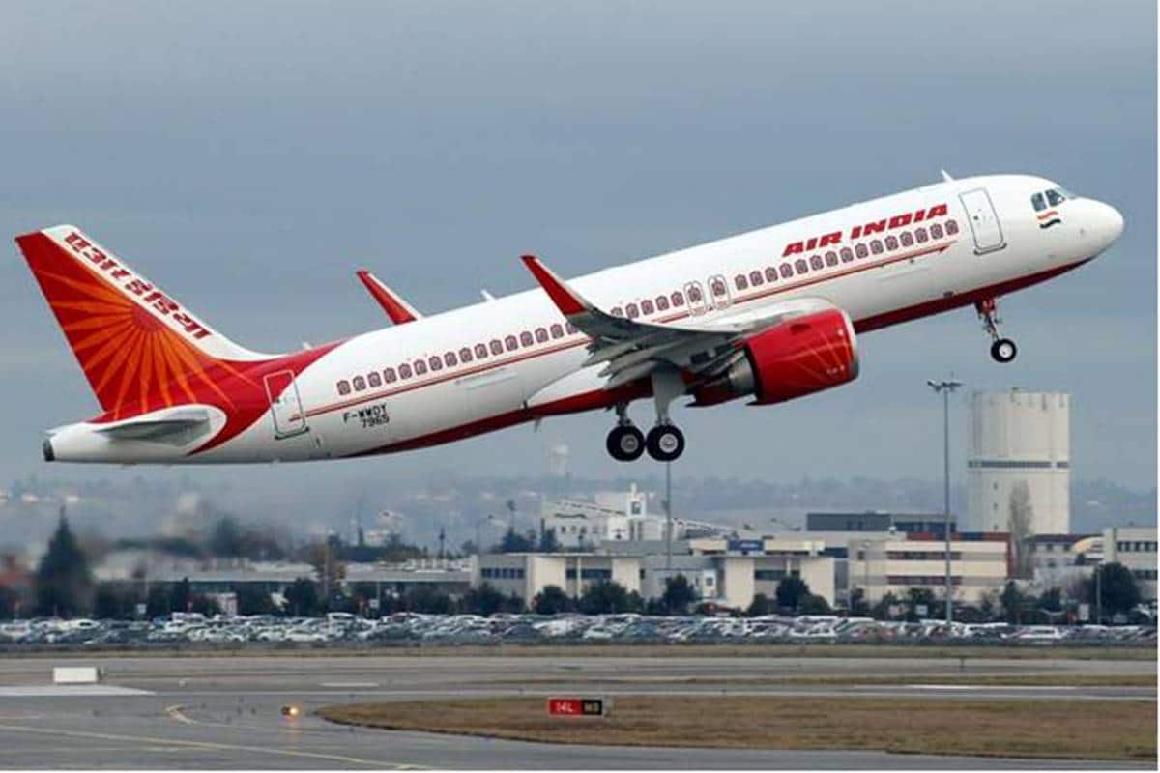

Task 1. Answer the questions.
- Have you ever flown by a plane?
- Where have you flown?
- How long was your flight?
- Describe the procedure of checking in / boarding the plane / going through the customs control.
Task 2. Read the text, write out the words given in bold and translate them into Ukrainian. Learn the words.
AIR TRAVELLING
You can book a flight either over the Internet or through a travel agency. Perhaps your secretary makes the booking for you. Your ticket can be single/one-way or return/roundtrip. It’s a good idea to check-in online in advance, as it increases the chance that you get a good seat. You can have a window seat, a middle seat or an aisle seat.
It is recommended to arrive at the airport 2 or 3 hours before the flight. When the taxi drops you off outside the terminal building, you enter the terminal and find the self-service check-in machine. You should enter your e-ticket reservation number or frequent flyer number, then you can choose your seat from those still available/open (if you haven’t already chosen), and the machine prints your boarding pass. If you have any checked baggage, you go to the baggage drop-off point. You should follow the signs for ‘Departures’ at the departure board and prepare for the security check. Sometimes you may have to queue (Am E stand in line) for a little while in order to go through the scanner.
Now you’re in the departure lounge. You can exchange your currency for the money used in a particular country or do some shopping at the duty-free shop. Keep checking the information screens to see the status of your flight. It might be delayed or even cancelled. When you see the announcement about your flight boarding, you walk to the gate and board the plane. It is recommended not to wait until the final call (=last announcement). When you are on board, find your seat and put your hand luggage in the overhead locker. Just before you take off, the flight attendants/cabin crew will give a safety demonstration. Now you’re in the air and can enjoy your flight! Let’s hope there isn’t too much turbulence.
When you land, get off the plane, and go through passport control. Follow the signs for baggage reclaim and collect your bags from the carousel/belt that has your flight number. Walk through the customs and exit at the barrier in the arrivals hall. Is anyone there to meet you? Maybe it’s a local contact who has come to pick you up, or maybe it’s a taxi driver holding up a sign with your name on it.
If you travelled on a long haul flight, you may have jet lag (= feeling very tired after a long flight). You’ll need a day or two to recover.

Task 3. Watch the first part of the video (0.00-2.35) on https://www.youtube.com/watch?v=DUqdQjkvElo and put the words into the correct order to build the sentences you may use while checking in.
- checked in / have / you / already / online?
- you / paper / of / your / copy / a / boarding / do / need / pass?
- have / do / any / you / to / bags / check in?
- have / I / a / only / bag /carry-on
- are / where / flying / you / to / today?
- you / confirm / have / a / vegetarian / can / that / I / meal?
- any / do / seats / in / you / the / exit / have / row?
- seats / exit / more / row / have / legroom, /they’re / often / so / comfortable more

Task 4. Watch the second part of the video (2.35-4.45) on https://www.youtube.com/watch?v=DUqdQjkvElo and fill in the missed words into the gaps.
- Justin: I’m sorry ma’am, but this bag is ________. The ________ is 23 kilos. You either need to take some things out, or ________ for the excess.
Stephanie: How much is the ________?
J: It’s ________ euros for a bag up to 32 kilos.
S: That’s ________! I’ll try to take some things out.

- S: I’m sorry, but the ________ is ________ by at least two hours.
J: So, when do you ________ the plane to ________?
S: Right now, we expect it to ________ at 10.30pm. I ________ apologize for the inconvenience.
J: Well, I ________ there’s nothing we can do.
S: Thank you for your ________. You can ________ the departure ________ for updated ________ times and flight _________.

- J: I’m sorry, but your flight has been ________ due to bad ________.
S: But, I really need to be in London tomorrow afternoon. When’s the next ________ flight?
J: Let me see what we can do… We do have a flight leaving _________ morning that I can ________ you to.
S: What ________ in the morning?
J: It ________ here at 7am, and ________ at 10.
S: Okay, that will be fine.
J: Right, here’s a ________ confirmation, and again I am very sorry for the ________.
S: That’s okay; it’s not your ________. Are there any hotels near the airport?
J: Yes, of course. If you go to the _________ service desk, just over there, you can claim a voucher for a hotel and _________.
S: Excellent, thank you.
J:You’re welcome.

Task 5. Watch the third part of the video (4.45-7.10) on https://www.youtube.com/watch?v=DUqdQjkvElo and write down six questions or requests that you might hear when going through security.

Task 6. Watch the fourth part of the video (7.10-10.00) on https://www.youtube.com/watch?v=DUqdQjkvElo and do the tasks.
- Write down 5 things you have to do during take-off and landing.
- Describe the problems you might have during the flight.

Task 7. Watch the fifth part of the video (10.00-11.45) on https://www.youtube.com/watch?v=DUqdQjkvElo and answer the questions.
- What can the border control officer ask you on arrival to the place of your destination?
- What answer can you give him?
Task 8. Imagine that you are at the customs control at the airport now. Practice answering the questions you can be asked.
- What’s your final destination?
- How long will you be staying in the United Sates?
- What is the purpose of your visit?
- Where will you be staying?
- How much currency are you carrying with you?
- Who packed your bag?
- Do you have anything to declare?
- Do you have any electronical or metal objects in your bag?

Task 9. Underline the correct word in italics.
1. Did you have a good travel / journey?
2. I booked / ordered my flight on the Internet.
3. I prefer an aisle / a corridor seat as I get more leg room.
4. Excuse me, I think that’s my seat. My boarding pass / ticket says seat 16A.
5. Oh no! The information screen says our flight is delayed by / with an hour.
6. Be quick – that was the final call / calling for our flight.
7. We were waiting on the runway for about 30 minutes before the plane finally took off / took up.
8. When you come out at the barrier, you’ll see our driver holding a sign / signal with your name on it.
9. The taxi bill / fare was over 60 euros – I’m sure the driver didn’t reset the meter before we left.
10. How much is the fare? 36 euros? OK – here’s 40 euros. Keep the change / small money.
11. Make it 50, and can I have a receipt / an invoice, please?
12. I got a really good deal / offering on my ticket – it was about 25% less than the regular price.
13. There was a traffic jam on the way to the airport and I nearly lost / missed my flight.
14. I was just sitting there, waiting / waiting for my flight to be called.
15. I did some shopping in the departing / departure lounge.
16. You can book a hotel in the arriving / arrivals hall.

Task 10. Match an item on the left with an item on the right.
1 make  2 be away  3 drop  4 pick  5 go through  6 walk  7 board  8 put  9 follow  10 cut | - you off at Terminal 1  - you up from Arrivals  - security/passport control  - a booking  - on a trip  - your bag in the overhead locker  - around and do some shopping  - short the trip  - the plane  - the signs for Baggage Reclaim

Task 11. Complete each sentence with a whole phrase from the previous exercise.
- If I need to _______ on a flight, my favorite Internet site is RidiculouslyCheapFlights.com.
- It will be a great pleasure to welcome you to Lisbon. We’ll take care of everything. A driver will ________ he’ll be at the barrier waiting for you.
- The taxi will be here in five minutes. Don’t worry – you should be at the airport in less than half an hour. I’ll ask the driver to _________.
- I’m sorry sir, you have to______ . It’s part of the safety regulations.
- There was an emergency at the factory – the workers were threatening to go on strike and my assistant was away on vacation. I had to ________.
- Before I _______ I always look around near the departure gate to see if there are any free newspapers.

Task 12. Match a word from list A with a word from list B to make word-combinations.

A: boarding check-in final flight frequent jet
hand overhead passport terminal

B: attendant building call control flyer lag
luggage locker machine pass

Task 13. Use a two-word phrase from the previous exercise and fill in the gaps. Then put the sentences in order (according to what really happens).
- The taxi drops you off outside the ___________.
- Try to be friendly to the local colleagues who are there to meet you,evenif you are suffering from ________.
- Enter the terminal and find the self-service _________.
- Before you go into the departure lounge, show your _______ to a security guard and then go through a scanner.
- Board the plane and put your _______ in the _________.
- Enter your e-ticket reservation number or ________ number on the screen.
- Pay attention while the ____________s give a safety demonstration.
- Check the information screen to see when your flight is going to board. Don't wait until the__________.
- When you land, go through __________.

HOTELS

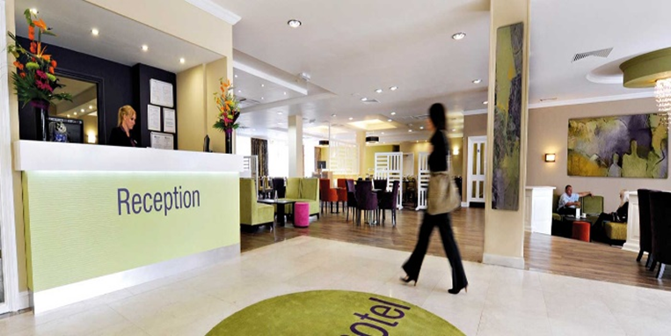

Task 1. Answer the questions.
- When do people stay at hotels?
- Have you ever stayed at the hotel? When was it? Describe your experience.
- What should you do to check in at the hotel?
- What services are usually offered at hotels?
- What facilities do hotels usually have?

Task 2. Read the text, write out the words given in bold and translate them into Ukrainian. Learn the words.
STAYING AT A HOTEL
The guest arrives at the hotel, walks into the lobby, and then goes up to the reception (= the front desk) to check in. The receptionist (= desk clerk) needs to get (= confirm) various details. These may include: name and address, nationality, passport details, a signature on a registration form, departure date and time and room preferences. Hotels usually offer double rooms (with a double bed), twin rooms (with two beds) or single rooms. The guest should also mention the rate quoted (=amount of money you were told you would pay) and whether he or the company pays. He also gives his/her credit card details, and any loyalty programs that he/she belongs to. Once this is complete, the receptionist will give the guest the key card and explain a few things such as breakfast arrangements and the location of hotel facilities.
Here are some of the facilities that may be available in a hotel: a business centre, a swimming pool, a gym/ a fitness room, a laundry and a dry cleaning, 24-hour reception, 24-hour room service, a restaurant. Hotels may also offer a complimentary (= provided free) newspaper, currency exchange, and an airport transfer / shuttle.
If you need anything extra, you may contact the reception or the room service clerk. You usually dial zero to speak to the reception.

Task 3.The guest may have the following questions to ask the receptionist. Put the words into the correct order to make questions.
- to help / Can / someone / with / you /get / me / my luggage?
- a wake-up / Can / have / I / in the morning / call?
- from / How far / the / is / Expo Centre / here?
- should / Can / walk / there / I / or / I / a taxi / take?
- you / tell / me / there’s / Could / if /near here / a bank?
- please / Can / an iron / ironing board / I / my room / have / sent up / and / to?
- the housekeeping / Could / morning / tell / not to clean / you / staff / in / my room / the?
- possible / breakfast / Is / sent up / my room / it / to have / to?
- could / Do / think / call up / you / my colleagues / you / and / let / know / me / when / to / my room / arrive?
- ask / Could / you / I / the weather / for / just / forecast / tomorrow?

Task 4. Read the text, write out the words given in bold and translate them into Ukrainian. Learn the words.
HOTEL COMPLAINTS: HOW TO COMPLAIN ABOUT A HOTEL
Here are just some of the things that you may want to complain about:
    - No reservation on arrival.
    - Wrong room allocation – you wanted a room with a view of the sea.
    - Poor housekeeping: room that hasn’t been cleaned, dirty sheets, dirty towels, no spare blanket.
    - Bathroom problems: shower not working, smell coming from the drains.
    - Air conditioning or heater not working.
    - Uncomfortable mattress or pillow.
    - Noise from loud neighbors, or from an event happening in the hotel.
    - Substandard restaurant.
Here are some tips on how to complain:
1. Take a photo with your mobile phone to help build your case. Then complain immediately – go down to the front desk and talk face-to-face.
2. Tell your story once, simply, and without exaggeration. Finish by identifying the solution you want (something fixed in your room or getting a new room). Then be silent and wait for a response.
3. Remain calm and polite at all times. You will get better service more quickly.
4. If they cannot fix your problem immediately, be flexible about back-up solutions. How about using a shower in another room if you are in a hurry?
5. If it is a serious matter, keep notes of who you talked to, when, and what was said. Then when you get back home, write to the Hotel Manager and ask for a partial refund.
Task5. Underline the correct word in italics.
1. I’ll be waiting in the hall / lobby, just in front of the reception desk.
2. Please fill in this registration form and sign / signature at the bottom where I have marked with a cross.
3. You are paying a special charge / rate for your room. It does not include breakfast.
4. Can you make sure I get my fidelity / loyalty points for this stay?
5. Can I have a get-up / wake-up call in the morning?
6. I have some clothes that need washing. Do you have a laundry / laundering service?
7. Please help yourself to a morning newspaper – it’s complimentary / a complement.
8. Is there an airport transfer / transportation? When do they leave?
9. I would definitely recommend the hotel. It had very good conditions / facilities.
10. I’m sorry, my room is incompatible / unsuitable – it’s right next to a noisy elevator.
Task 6. Fill in the missing letters.
  - Is it possible to upgrade my room to one that has a v _ _ _ of the sea?
  - This price is not the price I was qu _ _ed when I called you last week.
  - I’ll be down in half an hour – I just need to unp _ _ k my things and fr_ _ _ en up.
  - Can I change my euros into the local curr _ _ _ _.
  - Can I have an ir_ _ and ir _ _ing boa _ _ sent up to my room, please?
  - I’m sorry, but my room has not been cl _ _ _ed.
  - It’s cold and I might need a sp _ _ e blanket tonight. I can’t see one in the room.
  - There is an unpleasant sm _ _ _ in the bathroom – I think it’s the drains. I would like to change rooms, please.
  - My room is cold. I tried to adjust the controls on the he_ _er but they don’t work.
  - My pi_ _ ow is too high. Do you have another one – if possible one with feathers?
Task 7. Each sentence below contains one mistake (it might just be word order). Find it and correct it.
1. Can I to have a wake-up call in the morning?
2. How distance is the Expo Centre from here?
3. Can I walk or would I take a taxi.
4. What time do you stop to serve breakfast?
5. I can have an iron sent up to my room, please?
6. I need it so soon as possible.
7. Could you tell to the housekeeping staff not to clean my room in the morning?
8. Is it possibility to have breakfast sent up to my room?
Task 8. Watch the first part of the video (minutes 0.00-3.05) on https://www.youtube.com/watch?v=FJrRiVjeOMc&feature=emb_logoand fill in the gaps.
Kae: Hi, I’d like to ________ ___ ________.
Olivier: Yes, of course. When would you like to________ ___?
K: On the 3rd of November.
O: And ________ ________ ________ would that be for?
K: For three nights.
O: And ________ ________ ___ ________ were you looking for?
K: A ________ _________. It’s for my husband and me.
O: We do have one double room _________ for those dates. It’s $80 ___ ________ so that comes to $240 for the three nights.
K: Yes, that’s fine.
O: Great. Can I ________ ________ ________?
K: Yes, it’s Sarah Banks
O: Thank you, Ms. Banks. Can I just ________ ___ ________ _________ from you to make the ________?
K: Yes of course, _________ _________ ________.
O: Okay Ms. Banks, that’s all finished. Is there anything else I can help you with?
K: Yes, could I have a _________ emailed to me?
O: Yes of course, what’s the email?
K: It’s s dot banks at gmail dot com.
O: Okay, I’ll send that over to you now.
K: Excellent, thank you very much.
O: You’re welcome. We ________ _________ ___ ________ you.
K: Thank you, goodbye
O: Goodbye.
Task 9. Watch the episode of the video (minutes 3.05-4.38) on https://www.youtube.com/watch?v=FJrRiVjeOMc&feature=emb_logoand put the words into the correct order to build sentences.
- I’d / to make / a reservation / for / like / for / one / the 20th / night, / of / May / please.
- I’d / a triple / room / like, / please.
- don’t / We / any / rooms / available / have / on / triple / date / that.
- almost / It’s / period / booked / we’re / a holiday / and / fully.
- anything / I’m / on / afraid / we / have / dates / don’t / free / those.
Task 10. Watch the second part of the video (minutes 4.38-6.00) on https://www.youtube.com/watch?v=FJrRiVjeOMc&feature=emb_logoand answer the questions.
- How did Sarah Banks prove that she really had a room reserved at the hotel?
- Why did the problem with the reservation occur?
Task 11. Watch the third part of the video (minutes 6.00-9.39) on https://www.youtube.com/watch?v=FJrRiVjeOMc&feature=emb_logoand build 5 sentences asking about the hotel’s facilities (you may take the ideas either from the video or from your own experience).

Task 12. Watch the fourth part of the video (minutes 9.39-12.42) on https://www.youtube.com/watch?v=FJrRiVjeOMc&feature=emb_logoand put the words into the correct order to build complaints.
- issue / there’s / an / the / heating / with.
- normal, / I’m / not / my / if / sure / door / it’s / but / doesn’t / key / work / in / always / the.
- with / something’s / the / sink / the / in / wrong / bathroom.
- ventilation/ I / a / problem / with / there’s / think / the.
- make / to / I’d / a / like / complaint; been / my / hasn’t / properly / room / cleaned.
- unacceptable / say / to / I / have / is / this.
Task 13. Watch the fifth part of the video (minutes 12.42-14.22) on https://www.youtube.com/watch?v=FJrRiVjeOMc&feature=emb_logoand put the dialogue into the correct order.
- Very nice, thank you.
- Hi, I’d like to check out please.
- Here is a copy of your bill. The room and tax are already paid, so these are just the extras.
- Yes of course; how was your stay?
- Thank you, goodbye.
- Let me have a look…, OK, this payment is for the water and snacks you had from the minibar, and it looks like this is a phone call that was made to the USA.
- The total seems higher than I expected; what exactly are these additional charges?
- Right, I see now. Yes, that’s fine. I’d like to pay cash, if that’s OK?
- Yes, no problem. Thank you for staying with us.

Task 14. Match the beginnings and endings of the phrases. Then use them to complete the dialogue between a receptionist and a guest.
I’d like someone to help me ...
Can you if you could ...
Can you get to check in
Could I just of you
I’d be grateful give me ...
That’s ask you ...
That's very kind to follow the porter, ...
If you’d like right
Receptionist: Good morning, madam.
Guest: Good morning. ____________ I have a reservation in the name of Fiona Wilson, just one night.
R: One moment. Right, I have it here. We’ve put you on the fourth floor, overlooking the hotel gardens.
G: That sounds fine.
R: And the rate you were quoted is €150 a night.
G: ____________
R: ____________ to fill in this registration form?
G: Sure. Also, I have some heavy luggage in the lobby over there. ____ with it?
R: Yes of course. I'll get the porter to take it up for you. Was there anything else?
G: Yes. ___________ a wake-up call tomorrow morning?
R: Certainly. What time would you like?
G: It needs to be 5.45 am. My flight leaves at 8.00.
R: No problem.
G: ___________book a taxi for me as well. I guess I need to leave around 6.30am to get to the airport for check-in at 7.00.
R: Yes, 6.30 should be fine. At that time in the morning there’s very little traffic. And I can ask room service to bring you a coffee and a croissant at 6 if you'd like.
G: Oh, thank you very much. ___________
R: I’ll book the taxi right now. Here’s your key card. ______________ he’ll take you to your room.
FILLING IN FORMS

Task 1. Answer the questions.
- What is a form?
- When do we have to fill in forms?
- What types of forms do you know?
- What information is usually written in the form?
- Have you ever filled in any forms?
- What mistakes do people usually make when filling in forms?

Task 2. Read the text, write out the words given in bold and translate them into Ukrainian. Learn the words.
FILLING IN FORMS
We fill in forms for a wide range of purposes. For example, you might want to record a complaint or fill in a course or job application form. Or you might complete a form online to find out about jobs in your area or to book a ticket for a journey or a show.
Forms can be filled in different ways, including:
- by hand
- by word processor and signed by hand
- online (and sent online)
Some forms, such as accident-report forms, require you to organize and report on factual information. Others, such as job-application forms, require you to market or ‘sell yourself’ in addition to giving factual information about your experience and skills.
Some online forms can give you access to information on a database. This can save you time when you’re making travel plans, or when searching for job vacancies. You can also use online forms to make a purchase, such as booking a flight. Many companies or organizations will want you to register with their website and they’ll ask you to complete a registration form. In this case you will need to fill in your email address, as well as a user name and password in order to protect your personal details.
If you’re sending payment with a form, you have to be especially careful filling in the form, ensuring that all the details are correct. You may decide to send a cheque, credit card details, or complete a direct debit form or bank transfer. If you’re filling in your financial details online, you need to be sure that you are using a secure site. A secure site will have https in the address bar and there will usually be a padlock symbol on the screen.
Sometimes there are different types of questions in different sections of a form. There may be questions with a list of possible answers and you have to choose the answer that applies to you. When completing a form, you may often be asked to tick a box. You may also have to circle the right answer to a question, or cross out the wrong answers. If you’re completing a form on a computer, you may have to use the mouse to click on a drop-down menu and you then click on the answer that’s right for you.
It’s important to read a form carefully before filling it in. Are there different sections in the form? Do you have to answer different types of questions in different sections of the form? Do all sections apply to you? On some forms, such as online registration forms, you don’t have to answer all the questions. Questions that require an answer often have an asterisk next to them so these are the only ones you need to complete.
Before signing a form, make sure you understand what you’re committing yourself to. You won’t need to sign an online form, but it’s important to check the form very carefully before pressing the ‘send’ button to make sure that all the information is correct. It’s also a very good idea to print and save a copy of the form so you have a record of what you’ve completed and sent. This may also be helpful for the next time you need to complete a similar form.

Task 3. Match the word or abbreviation to its meaning.
- For office use/official use only | - Your sex is whether you are a man or woman, male or female
- N/A | - The first letter of your forenames and surname
- Forenames | - Your nearest or closest relative
- Signature | - Write the whole word in capital letters
- Next of kin | - Any family members who rely on you for financial support
- Title | - Your National Insurance Number
- Dependants | - You need to enter your citizenship
- Marital status | - Put a tick in the box that’s right for you
- Initials | - Give details
- N.I.No. | - The country you were born in
- Write in BLOCK CAPITALS | - Say if you are single, married, in a civil partnership, widowed, divorced or separated
- Tick the box | - Your first names (not your surname or family name)
- Specify | - The initials of each word Date of Birth
- DOB | - How you sign your name
- Country of origin | - Mr/Mrs/Ms/Miss, etc
- Gender | - Not applicable
- Employment status/ Occupation | - Not to be filled in. This section is completed by the organization
- Country of Citizenship | - Are you employed, unemployed, self-employed, a carer, etc.

Task 4. Follow the instructions and complete each section of the form for Maria.
Maria Webster is 34 years old and single. She lives at 47 Harewood Court, Dunstan Road, Bingley, YA2 3EW. She does not have a driving licence. She has a visual disability and is registered disabled.

Please complete in black ink and write in block capitals

Full name:................................................................................................................

Title (please circle as appropriate): Mr/Mrs/Ms/Miss/Other ..............................

Address (including postcode): ..................................................................................................................................
..................................................................................................................................

What is your age group? Please tick as appropriate:
Under 18 years □ 18-25 years □ 26-40 years □ 41-60 years □ Over 60 years □

What is your marital status (please tick as appropriate):
Single □ Married □ Civil Partnership □ Divorced □ Separated □ Widowed □

Please answer Yes or No:
Do you have a full driving licence? ____ Are you registered disabled? ____

Your signature: ................................................................

Today’s Date □□□□□□□□

Task 5. You are to take part in the international conference in Romania. Fill in the hotel reservation form.
Regional Conference for Central and Eastern Europe and Central Asia
Making laws work to end violence against women and girls

HOTEL REGISTRATION FORM
11-14June 2017, Bucharest (Romania)

DELEGATION OF
□ Ms. / □ Mr.
First Name |  | Family name
Address
Country |  | City
Telephone |  | Cell phone
E-mail

Date of arrival |  |  |  | Time of arrival
Date of departure |  |  |  | Time of departure

Room rate:
120 EURO/ Single room / night. Rate includes: Full American Breakfast for one person, access to World Class Academy and local tax (9% VAT and 1% city tax)
130 EURO/ Double room / night. Rate includes: Full American Breakfast for two persons, access to World Class Academy and local tax (9% VAT and 1% city tax)

Rooms can be booked until 13th of May, 2017 at the above mentioned rates, upon room & rates availability.

Local taxes (VAT and city tax) are subject to governmental change without further notice.

Additional requests:
Non-smoking room Room with 1 King Size Bed Room with 2 Double Beds

PLEASE NOTE THAT A LIMITED NUMBER OF ROOMS ARE AVAILABLE FOR EACH RATE CATEGORY. PLEASE REGISTER EARLY.

Method of guarantee and advance payment:
*You can use one of the following Credit Cards:
American Express Visa MasterCard/EuroCard

Card Number: ………………………………………………………….. Exp. Date. …………………...

* For your safety, in case the name that appears on the credit card is different than that of the guest for which the bedroom is reserved, we require a credit card authorization form to be signed by the card owner prior to guest arrival. We will email this form as soon as you notify us.

yes, I’m the owner of the credit card. I’m not the owner; please email/fax me the authorization form.

Cancellation and No Show:
Starting with 13th of May, 2017, any cancellation will be charged for the first night’s stay.
Any decrease in length of stay within 3 days before arrival will be 100% charged. Any guest room reservation confirmed and guaranteed through the Reservation Form, but not claimed on the day of arrival (no show), will be cancelled and will only be re-entered into the reservation system subject to space availability. In this case all nights will be charged the calculated room rate plus taxes.

Other information:
Check-in time: 3.00pm Check-out time: Noon

…………………………………………….. …………………………………….
Date Signature

The reservation is confirmed upon receipt of the confirmation number from the hotel.
Task 6. Match answers to the questions. Read and translate the given information, write out and learn the words given in bold.
- What is a visa? | a) It is a type of nonimmigrant visa that allows the bearer to enroll at a postsecondary educational institution in the host country. High school foreign exchange students must typically obtain a visa for temporary residence.
2. What is a work visa? | B) Travellers may sometimes require them in order to pass through a country that is not their destination country. They are typically required if you have a layover in a country of more than a few hours.
3. What is a student visa? | c) It is an official document that allows the bearer to legally enter a foreign country. The visa is usually stamped or glued into the bearer’s passport. There are several different types of visas, each of which afford the bearer different rights in the host country. However, if your home country has a visa agreement with the country to which you intend to travel, then you likely will not need to apply for a visa.
4. What is a working holiday visa? | D) These are required for individuals who wish to take on employment or engage in business activities in the host country. There are several types of such visas that depend on the nature of the work and length of stay. For example, working holiday visas allow individuals to temporarily take on employment while travelling through the country.
5.What is a transit visa? | e)These visas can be separated into two categories. The first allows the bearer to reside permanently in the host country, whereas the second allows the bearer entry into the host country on a temporary basis.
6.Immigrant vs. nonimmigrant visas | f) Such visas allow the bearer to undertake temporary employment in a country through which they are travelling. Many are intended for young travellers and have an age restriction (usually from 18 to 30 or 35).There are usually limits on the type of employment taken or the length of time the traveller can be employed. Not every country offers such a program.
7.What is a travel/ tourist visa? | g) It allows the bearer to enter the host country and engage in business activities without joining that country’s labour market. For example, an individual may require it if they are travelling to a country to do business with another company or if they are attending a business conference. The visitor typically must show that they are not receiving income from the country.
8.What is a business visa? | h)Such visas allow partners to visit each other when the couple does not come from the same country.
9.What is a refugee/ asylum visa? | i)Such visas allow the bearer to enter a foreign country for touristic and leisure purposes only and stay for a predetermined amount of time. They do not entitle the holder to work or engage in any business activities in the host country.
10.What is a spousal visa? | g)It is a digital visa that is stored in a database rather than stamped or glued into the bearer’s passport. It is linked to the individual’s passport number. Applications for such visas are typically done over the Internet and the applicant will receive a paper document to present while travelling.
11.What is an e-visa? | k)They can be granted to individuals fleeing persecution, war, natural disasters and other situations in which their life is at risk.

Task 7. Read the statements and decide which type of visas you will need.
- You are travelling to Australia with a layover of 2 days in Malaysia.
- Your country is at war and you have to save your life.
- Your wife / husband has an American citizenship.
- You are young and you would like to see the country but you need to earn money to do it.
- You’ve decided to get the Master’s Degree abroad.
- You would like to go to Mexico during your annual vacations.
- You are a representative of a Ukrainian company and would like to close a deal with your German partner.
Task 8.Watch the video ‘How to fill the Schengen Visa application form’ on https://www.youtube.com/watch?v=BbilCh6ZIIQ
Task 9. Download the Schengen Visa application form from https://www.schengenvisainfo.com/download-schengen-visa-application-form/ and fill it in.
Task 10. Choose the correct variant.
1. DOB stands for:
a) Day of bouncing
b) Date of birth
c) Don’t over book
2. Another name for your first name is:
a) Forename
b) Surname
c) Last Name
3. Your country of origin is:
a) Where you were brought up
b) Where you were born
c) Where you go on holiday
4. Gender means:
a) Your sex - male or female
b) Children
c) Where you were born
5. Your dependants are:
a) Your cousins
b) Your friends
c) People you provide for
6. Your occupation is:
a) If you are married or single
b) Your work
c) Your work history
7. Many companies will want you to register with their website and ________ a registration form.
- compile
- complete
- create

- You will need to fill in your email address, as well as a user name and a password in order to ________ your personal details.
- preserve
- provide
- protect

CONFERENCES AND TRADE FAIRS

Task 1. Answer the questions.
- Have you ever taken part in any conferences?
- What is usually discussed at the conferences?
- Who usually visits conferences?
- Why do people visit conferences?
Task 2. Read the text about conferences, write out and translate the words given in bold.
CONFERENCES
Are you a speaker / presenter who is giving a speech / presentation / talk, or a participant / delegate who is attending (= going to) the sessions? There are many kinds of presentations, including:
- A workshop session. This is likely to be practical and aimed at improving skills.
- A seminar: This is a meeting for giving and discussing information.
- A round-table discussion. This is a discussion with several speakers, under the control of a moderator / facilitator. One common format is where a panel of experts answer questions from the audience.
- A plenary. This is a session attended by everyone at the conference.
The conference takes place at a venue (= place where a large event happens) such as a convention centre.
After registration in the foyer / lobby, the day is organized into time slots with several sessions usually happening at the same time. Inside the venue there is an exhibition area where exhibitors have stands / booths to give information or sell their products. There is some area for refreshments, and also several breakout areas with places for people to sit and talk. This is very important – to most people the opportunity to network is just as important as attending the talks.
Every conference has an opening / closing address. This is a formal speech given at the start / end of the conference. It may take place in a large auditorium. And there is often a keynote speech. It introduces the main issues to be considered at the conference.
You walk away from the conference with all sorts of papers in your conference pack. There will be the promotional material you picked up on the stands, the handouts that the speakers gave out / passed round, and hopefully lots of business cards that you exchanged with useful contacts.
Task 3. How do you usually arrive at the conference? Put the events in the correct order. The first one is already given.
TRAVELLING TO A CONFERENCE
- Arrive at your hotel
- Board the plane
- Check your flight status 1
- Get your bags at baggage claim
- Make a new contact while in the air
- Meet your colleagues at dinner to discuss the conference
- Pick up your rental car

Task 4. Read the text about exhibitions and trade fairs, write out, translate and learn the words given in bold.
EXHIBITIONS AND TRADE FAIRS
An exhibition often takes place in the same kind of venue as a conference, but here the emphasis is on the visitors walking around the stands and talking to the exhibitors. There may also be a few conference-style sessions to add interest. An exhibition may also be called an expo. A trade fair / trade show is very similar but is for one particular industry rather than the general public.
Exhibitors invest a lot of money in the event. Costs include rental of stand space, design and construction of displays for the stand, travel, accommodation, and promotional literature and items to give to visitors.
An increasing number of trade fairs are happening online, and these events are called virtual trade shows.
Task 5.Answer the questions.
- Have you ever been to a trade fair? What was the experience like?
- If no, what kind of an exhibition or a trade fair would you like to visit one day?
Task 6. Rank the reasons for going to a trade fair in the order of importance.
- To keep up-to-date with trends in your industry
- To attend workshops and demonstrations.
- To see what your competitors are doing
- To get an overview of the market
- To promote your business
- To keep in touch with your existing customers
- To check out the latest innovations
- To make new business contacts
What other reasons are there to go to a trade fair?

Task 7. Match the verbs on the left to the words on the right to make phrases for things that you need to do to prepare for a trade fair.
- rent  - schedule  - ship  - promote  - prepare  - register  - set | - a budget  - attendees  - floor space  - marketing materials  - meetings  - the stand and equipment  - your brand

What else should you do before a trade fair?

Task 8. Below are questions that a company representative might ask a visitor of a trade fair stand. Put the words into a right order and match them to the answers.
- What/ you / area of the industry/ work in/ do?  - Can I/ about the company/ tell you/ and our products?  - Could I/ business card/ get your?  - Can you/ for a meeting/ stop by/ tomorrow?  - Are you/ to buy something/ looking at the moment?  - Are you/ the fair/ enjoying?  - Are you/ with our company/ familiar? | - I’m in product design.  - Not right now.  - Yes, here you are.  - Yes, I’m free at 11 am.  - Yes, it gets better every year.  - Yes, please do.  - Yes, we use some of your products.

Task 9. Complete the gaps in the email with the verbs below.
arrange communicate discuss hesitate impress meet supply talk

Dear Graham Elliott,
It was pleasure to … you at Future Expo 2020. I thought the event was very good this year, and I was …ed with the organization.
As we were not able to find a time to … during the fair, I am contacting you to … the products in our ‘Future paint’ range, and your wish to … them to the US market.
We can … be email or by Skype, or we can … to meet in person.
If you have any other questions about the company at this time, please don’t … to ask.
Best regards,
Ms. Stephanie Lambert, Sales Director
Modern Paints, Bristol, United Kingdom

Task 10.Choose the best word to complete each of the sentences below.

complete eventful hectic low-budget profitable worthwhile
1. The trip was a … disaster. The flight was delayed and we didn’t manage to close the deal.
2. The trip was … . We met some potential clients that could help grow the business.
3. It was quite … . Our driver got lost several times and there was even a fire at the hotel!
4. It was very … . We had a lot of meetings in only a few days and had to travel a lot.
5. We chose … options for the trip to keep down costs.
6. It was very … . The trip didn’t cost a lot and we got some big orders on the new product.
Task 11. Talk about your past business trip. Try to use the vocabulary from this lesson. (If you haven’t been on any business trips yet, try to predict how it will be). Be sure to mention:
- the purpose of the trip
- what preparations you made
- what events took place during the trip
- explain how you felt about the trip.

Task 12. Here is a list of phrases used by an exhibitor and by a visitor. Differentiate which one belongs to whom and put them into the proper column.
- Can I help you? Please sit down. It’s quieter over here – we can talk without being disturbed.
- Can you tell me a little more about ... ?
- We’re thinking of changing our ... and we want to see what is available on the market.
- I see from your name badge that you work at ...
- I’m already a customer of yours – I use your ... .
- I’m interested in ... I work for a company that ...
- I saw that you were looking at ... .It’s our latest model. You can see the quality.
- What kind of thing are you looking for?
- I’d like to know what upgrades are available.
- We have it on display over there at the back of the stand.
- I’m not interested in buying at this stage, 1 just want to collect more information.
- I was looking at a similar product on the stand over there – what is the difference between these products?
- Let me give you a catalogue/brochure - it explains everything we’ve talked about.
- Do you have any samples?
- Here’s my card – please feel free to email or call at any time.
- Is it available in other colours / sizes?
- I’m here to help.
- If you leave your details, I’ll get our technical people to call you.
- What are your usual delivery times?
- Let me give you a catalogue.
- What kind of after-sales service do you provide?

An exhibitor | A visitor

Task 13. Complete the dialogue at a trade fair with the words in the box.

a sample at this stage key features leave your details name badge suit your needs ideal solution thinking of changing very advanced design what is available

Exhibitor: Can I help you? I see from your (1) … that you work at KLG. I must say your new product line is just fantastic.
Visitor: Thanks very much. Actually we’re (2) … the power units we use in our machines. I’m here at the fair to see (3) … on the market. I was just looking at the photographs behind the desk over there.
E: Yes, they show our new line of power packs. They feature cutting-edge technology and a (4) … . I’d like to say, we own the patent on the design.
V: Can you tell me a little more about the units?
E: Yes, of course. Please sit down. It’s quieter over here – we can talk without being disturbed.
V: I must emphasize that I’m not interested in buying (5) … . I just want more information.
E: No problem. I can run through the (6) … now, and then leave you with a brochure that you can look at later.
V: Fine.
E: Can I just ask what kind of power pack you are looking for?
V: Yes. We’re going to need a 10 watt power supply, chassis mounted. It must have full universal AC input, from 85 to 264 volts. The space available is quite small –around 70 by 30 by 20 millimetres.
E: I see. I think I have the (7) … for you. Have a look at this item from our brochure – it would (8) … very well.
V: Yes, it does look like the kind of thing we need. Do you have (9) … I could take away and show to my colleagues back at the office?
E: Not here, but if you (10) …, I’ll make sure we send one to you.

Task 14. Listen the audio “The London Conference” https://www.esl-lounge.com/student/listening/b1L2-the-london-conference-2.php Listen to Jenny reporting to her boss about a business conference in London. Read her notes about the trip and complete each space with a maximum of THREE words.
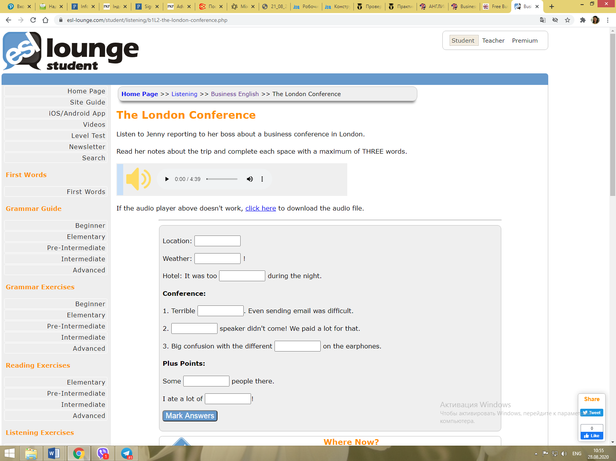

Task 15. Listen to Jenny reporting to her boss about a business conference in London. Match the people on the left with the actions on the right. Write just a number in each space.

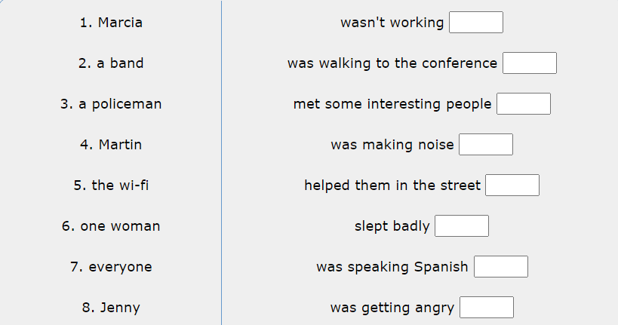
Task 16. Imagine that you are at the trade fair. Act out a dialogue with your group mate (one of you is an exhibitor and another one is a visitor). Use the phrases from the previous exercises.
Task 17. Choose the correct variant.
- I went to a very interesting … .
- discourse
- speech
- talk
- Which … are you going to after lunch?
- seminar
- talkshop
- workshop
- This year the conference … in South Africa.
- is being held
- is holding
- is taking place
- There’s a talk I really want to go to at 11 am. Do you mind if I’m not … for an hour or so?
- on the display
- in the booth
- on the stand
- The most useful thing about the conference was the opportunity to … .
- do contacts
- make contacts
- network
- Which session are you going to … after lunch?
- assist
- attend
- go to
- Before I pack my bags tonight I’m going to throw away most of the promotional … I was given.
- literature
- material
- notes
- We always have a stand at the Munich … .
- trade exhibitor
- trade fair
- trade show
- This is our … model. You can see the quality.
- later
- latest
- most recent

SUCCESSFUL PRESENTATION


Task 1. Answer the questions.
- When do people usually make presentations?
- Is it easy to keep your audience’s attention while presenting?
- How can you arise interest to your topic?
- Have you ever given presentations? Describe your experience.
Task 2. Imagine you have to give an important presentation in English tomorrow. Which of the following would you want to include in your presentation? Explain your choice.
- your name;
- you nickname;
- the subject of your presentation;
- details of your job;
- some gossips;
- details of the background situation;
- some jokes;
- the purpose of your presentation;
- a summary;
- main points you are going to cover;
- visual aids;
- factual information.

Task 3. Read the text about effective presentations, translate and learn the words given in bold.
EFFECTIVE PRESENTATIONS
Does the thought of speaking in front of others send you running in the opposite direction? You’re not alone. The idea of speaking in public can be frightening enough if you’re a native English speaker, but it’s even more so if English is your second language. Many people avoid public speaking at all costs – and there is a cost. Public speaking is one of the quickest, most efficient ways to market yourself, your ideas, your message, business, etc. Those who are willing to make presentations immediately stand out from the majority who are not. Whether it’s an audience of five people or 500, it’s worth it to invest in your skills.
If you want your presentation be a success, pay attention to following tips.
- ANALYSE YOUR AUDIENCE
Put yourself in the audience’s shoes – try to understand your listener’s level of understanding, their map of reality, and anticipate what they want to know. To give an effective presentation, you need to know something about your audience. How good is their English? How much do they know about the subject of your talk? Why will they be interested in listening to you? It’s a good idea to find out who is attending your presentation so that you can make the information relevant and interesting to them. Once you know what your audience wants, you can figure out how to ‘sell’ the benefits of your topic to them.
Also ask yourself what you want to achieve from your presentation and plan it in accordance with your goals. Remember that structure of sales presentations will differ from information-giving presentations, for example. It’s always a good idea to work out what you want your audience to think or do at the end of your talk, as this will help you focus on the language and content of your presentation.

- USE A STRONG OPENING STATEMENT OR QUESTION TO INTERESTYOUR AUDIENCE
The first minute of your presentation is crucial. In this time, you should interest your audience and give them a reason to listen to you. What you say in the first minute depends on your audience and their interests, but it must mean something important to them. Perhaps it is a problem that you know how to solve, or a fact or statistic that they need to know.

- PLAN THE CONTENT OF YOUR PRESENTATION
Planning helps you focus on your presentation goals, and minimizes the chances of anything going wrong. You can decide what information to include and how to order it. Aim to speak for no longer than 30 minutes, and leave time for questions and answers at the end. Remember that it’s difficult to absorb lots of new information, so don’t aim to include too much. Your information has to be interesting and up-to-date. So, you have to prepare thoroughly.
Make brief notes about all the points you want to make in your presentation and prepare a plan. Organize your presentation into main points and give supporting evidence. During the presentation, remember that it is a good idea to refer back to your opening statement and remind your audience why they are listening to you.

- MAKE THE PRESENTATION WELL-ORGANISED
Many presentations are divided into five areas:
- The introduction
- The overview
- The main body of the presentation
- The summary
- A question and answer session

- MAINTAIN INTEREST OF YOUR AUDIENCE
If you don’t pay attention to these items, you can lose the interest of your audience:
- Make eye contact.
- Use body language.
- Show you’re happy to be there.
- Move around. Avoid using podiums.
- Show your audience what you tell them.
- Present your information instead of reading your notes.
- Use visual-aids.
- Vary your activities and presentation modes.
- Get the audience involved.
- Be a good listener.
- Be yourself.

- KEEP VISUALS SIMPLE
Don’t put too much information in visuals and only use them to illustrate information that would otherwise take too long to explain. Simple graphic visuals such as pie charts and bar graphs work better than visuals with lots of labelling or words. Use color and different fonts to help information stand out.

- THINK ABOUT POSSIBLE QUESTIONS AND PRACTICE ANSWERING THEM
You’re likely to have questions at the end of your presentation, so try to predict some of them in advance, as well as think over possible answers. The more you prepare these, the better you’ll feel able to deal with them.

Task 4. Answer the questions to the text:
1. What is the aim of public speaking?
2. Why should you analyze your audience?
3. Why is it necessarily to ask yourself what you want to achieve from the presentation?
4. Why is the first minute of the presentation so important? How can you interest the audience?
5. What parts can a presentation be divided into?
6. What visuals are preferable?
7. Should you prepare questions and answers in advance?
8. What other things are important to keep your audience interested?

Task 5. Match words to their meanings.

1. summary | - a circle divided into parts by lines coming from the centre to show how big the different parts of a total amount are
2. message | - a short statement that gives the main information about something, without giving all the details
3. planning | - a spoken or written piece of information that you send to another person or leave for them
4. point | - a picture of boxes of different heights, in which each box represents a different amount or quantity
5. pie chart | - the process of thinking about and deciding on a plan for achieving or making something
6. bar graph | - facts or signs that show clearly that something exists or is true
7. visuals /  visual aid | - a single fact, idea, or opinion that is part of an argument or  discussion
8. evidence | - something such as a picture or the part of a film, video etc that helps people understand, learn, or remember information

Task 6. Read phrases A-J that can be used for organizing and sequencing points in a presentation. At which step of the presentation would you use each of them? Match phrases A-J with 5 steps of the presentation. Two phrases correspond to one step.
STRUCTURING A PRESENTATION
- My presentation is divided into three main sections. | - the introduction / opening statement
- Thank you for listening – and now if there are any questions, I would be pleased to answer them. | - the introduction / opening statement
- Have you ever asked yourself why ... ? | - the overview
- So, that was our marketing strategy. In brief, we… | - the overview
- This chart illustrates the figures… | - the main body of the presentation
- I’d be grateful if you could ask your questions after the presentation. | - the main body of the presentation
- Today I’m going to talk about... | - the summary
- Thank you. So you would like further clarification on our strategy? | - the summary
- Now let me summaries the main points again. | - a question and answer session
- Another interesting thing to say about … is… | - a question and answer session
Task 7. Watch the first part of the video ‘How to Give a Presentation’ (0.00-3.50) onhttps://www.youtube.com/watch?v=fzIxD1jXn44 and do the following task. Use the language from the video to do it.
- Practice introducing yourself informally, and explain the topic of your presentation in a simple way, with one sentence.
- Practice introducing yourself formally, and explain the topic of your presentation in a more detailed way.
Task 8. Watch the second part of the video ‘How to Give a Presentation’ (3.50-7.30) on https://www.youtube.com/watch?v=fzIxD1jXn44 and answer the questions.
- What are the three techniques of attracting the audience’s attention mentioned in the video? Name them and give examples.
- Which technique would you prefer to use, and why?
Task 9. Watch the third part of the video ‘How to Give a Presentation’ (7.30-11.50) on https://www.youtube.com/watch?v=fzIxD1jXn44 and answer the questions.
- What is the signposting language?
- Why should it be used?
- Give examples of signposting language.

Task 10. Watch the fourth part of the video ‘How to Give a Presentation’ (11.50-16.17) on https://www.youtube.com/watch?v=fzIxD1jXn44 and do the tasks.
- Give examples of the phrases you can use if you can’t remember what to say next.
- Give examples of the phrases you can use if you made a mistake in your presentation.
- Give examples of the phrases you can use if you forgot to mention something important.
- Explain what you will do if you can’t answer a difficult question.

Task 11. Translate sentences from English into Ukrainian.
1. The presentation went extremely well, with almost all of the audience requesting
further information about our proposals.
2. The first goal of the study was to define what power strategies were actually used
by these managers.
3. The aim of the first chapter is to provide a general overview of the subjects that will be covered.
4. The results of the survey are presented in three sections, each of which begins with a summary of its major findings.
5. A little forward planning can save you a lot of expense.
6. A bar graph shows present depth and maximum depth reached.
7. Any visual aid should be carefully selected and planned to add clarity to the presentation.
8. We can’t make a decision until we have all the relevant information.

Task 12. Read, translate and memorize the following phrases that can be used when presenting.
Overview:
‘My presentation is in three parts.’
‘My presentation is divided into three main sections.’
‘Firstly, secondly, thirdly, finally…’
‘I’m going to talk about / examine / tell you about / give you some facts and figures…’
The main body of the presentation:
- During your presentation, it’s a good idea to remind your audience occasionally of the benefit of what you are saying.
‘As I’ve said at the beginning…’
‘As you remember, we are concerned with…’
‘This relates directly to the question I’ve put to you before…’
- Keep your audience with you. Remember that what you are saying is new to your audience. Try to express your ideas clearly. Let your audience know when you are moving on to a new point. You can use some of the following expressions:
‘I’d now like to move on to…’
‘I’d like to turn to…’
‘That’s all I have to say about…’
‘Now I’d like to look at…’
‘This leads me to my next point…’
- It’s important to introduce the visual you are using at your presentation to the audience. You can use the following phrases:
‘This graph shows you…’
‘Take a look at this…’
‘If you look at this diagram, you will see…’
‘I’d like you to look at this…’
‘This chart illustrates the figures…’
- Give your audience enough time to absorb the information on the visual. Pause to allow them to look at the information and then explain why the visual is important:
‘As you can see…’
‘This clearly shows …’
‘From this, we can understand how / why…’
‘This area of the chart is interesting…’
Summarising.
- At the end of your presentation, you should summarise your talk and remind the audience of what you have told them:
‘That brings me to the end of my presentation. I’ve talked about…’
‘Well, that’s about it for now. We’ve covered…’
‘To summarise, I…’
- Relate the end of your presentation to your opening statement:
‘So I hope that you’re a little clearer on how we can achieve …’
‘To return to the original question, we can achieve…’
‘So just to round the talk off, I want to go back to the beginning when I asked you…’
‘I hope that my presentation today will help you with what I said at the beginning…’

Task 13. Read an example of a presentation and identify its parts.

Good morning ladies and gentlemen! We haven’t all met before so I’d better introduce myself. I’m Luis Lopez from the Development Department of Citrus Incorporated. I should say before we start that I hope you’ll excuse my English, I’m a little out of practice…Anyway, I’m going to be talking this morning about a new product which we are planning to launch in two months’ time. It’s called COOL-OUT, that’s C-O-O-L dash O-U-T, and it’s a lemon-flavoured drink.
Well, I’ll start with the background to the product launch and then move on to a
description of the product itself. Finally, I’m going to list some of the main selling points that we should emphasize on in the advertising and sales campaign. I think if you don’t mind, we’ll leave questions to the end...
Now firstly, as you all know, we have had a gap in our soft-drink product range for the last two years. We have been manufacturing mixed-fruit drinks and orange drinks for the last ten years, but we stopped producing lemonade two years ago. I think we all agreed that there was room on the market for a completely new lemon-flavoured drink. Secondly, the market research indicated that more and more young consumers are using soft drinks nowadays so, in other words, the market itself has expanded. This brings me to my next point which is that we have a rather new customer-profile in mind. I must emphasize that this product is aimed at the young professional, high-income, market and not the traditional consumer of old-fashioned lemonade. At this point we must consider the importance of packaging and design, and if you look at the video in a moment, you’ll see that we have completely re-vamped the container itself as well as the label and slogan. I should admit that a more sophisticated packaging means a high unit cost, and this may be a problem in the selling area, but we’ll have a chance to discuss that aspect later. So, to go back to my earlier point, this is a totally new concept as far as Citrus Incorporated are concerned. As you see we are using both the new-size glass bottle and the miniature metal cans. Finally, let’s look at the major attractions of the product. In spite of the higher price it will compete well with existing brands; the design is more modern than any of the current rival products, and incidentally the flavour is more realistic and natural. It’s low calorie, too.
O.K., so just before closing, I’d like to summarize my main points again. We have COOL-OUT, a new design concept, aimed at a relatively new age and income group. It’s designed to be consumed on its own, as a soft drink, or to be used as a mixer in cocktails. It comes in both bottle and can and this will mean a slightly higher selling price than we are used to; but the improved flavour and the package design should give us a real advantage in today’s market.
Well, that’s all I have today for the moment, thank you for listening, now if there are any questions, I’ll be happy to answer them.

Task 14. Read another example of a presentation and identify its parts.
Do you find it difficult to say ‘no’? I’d like to talk this morning about how managing your time more effectively can make you a better worker and to show you that other people’s demands on your time can make you less effective.
First of all, if you regularly work very long hours, are in the office most evenings and weekends, and rarely take a holiday, you might think that this is necessary in order to justify your salary. But in fact, what you are doing is subjecting yourself to high levels of stress which in the long term will force you to take time off through illness – so, why not organize your time now so that you remain effective at work and lead a balanced life? If you don’t believe me, this chart shows you how many stress-related diseases we now suffer from. As you can see, these diseases are most common not necessarily in jobs where salary levels are high but where the level of responsibility is high. Remember that not only you but also your family suffers as a result of stress.
Turning to my second point, if you spend part of your working day doing things
for others which they could do for themselves and if you work longer hours than the
people you work with, then perhaps it is time for you to delegate. I would like to develop this point and I hope I can give you some practical suggestions as to how you can do this.
First of all, you have to decide what to delegate. Secondly you have to decide who to delegate to. Make sure the person wants and accepts the extra responsibility and has the necessary experience to do the job well. Give them all the support they need but do not do the job for them. This will help you to use your time more effectively.
To conclude, if you have difficulty saying ‘no’ to other people, start saying ‘yes’ to yourself. Believe me, you will notice the difference.

Task 15. Prepare your own presentation. Choose the topic in accordance with your specialty and interests. Use the vocabulary from the previous exercises.
PROJECTS. GRAND PROPOSALS

Task 1. Answer the questions.
- What is a project?
- Have you ever done any projects?
- What projects did you work on at the University?
- What project are you working at now?

Task 2. Read the text about projects, write out and translate the words given in bold.
A project is a complex series of tasks that have to be completed within a specific time period and with limited financial resources. People can work on a project alone or with other people in a team. Projects can be big or small, but it is always important to know the aim. Many projects have a deadline, a fixed date when they need to be finished. Important projects usually have a project manager responsible for the budget and schedule. Successfully managing a project involves estimating and controlling the resources, budget and time schedule necessary for a positive outcome. Starting with the specifications of a project, project managers put together a project plan which will enable them to complete the work on time and on budget.

Task 3. What makes a project successful? Put the following items in order of importance (1 = most important). Give your arguments.
- a deadline
- good communication
- an aim
- a good team
- a team leader
- a budget
Task 4. Watch the video ‘Introduction to Project Management’ on https://www.youtube.com/watch?v=BOU1YP5NZVA and answer the questions.
- What is a project?
- What are three main features of projects?
- What are the phases of the project management?
- Why is it necessary to manage the project?
- Why do projects fail? (name 4 reasons)
- Who manages a project?
- What are the skills of a project manager?

Task 5. Projects follow a life cycle which has 4 phases:
Initiate plan execute/control close
Which of the following tasks would be included in each of the phases above?
- review the results
- evaluate the risk factor
- forecast costs
- select the project team
- deliver the project
- launch a pilot project
- obtain status reports validate the project
- allocate resources
- prepare a project overview

Task 6. Listen to a talk by a project leader about her project. Complete the talk with the correct words in italics.
I’d like to tell you about a project that my team finished last month. The aim / plan of the project was to produce a website to help international employees improve / increase their English. There were three / five stages. First, we agreed on a budget of $13.000/ $3,000. Next we planned the schedule. We had four months/weeks to arrange everything. After that we did research. We emailed/talked to international employees about the information / facts they wanted on the website. Then we had regular meetings to discuss progress / problems. Finally, we designed the website when we had all the information that we needed. The project succeeded because we were a good team and we had good communication.

Task 7. Study the diagram. Think of a project that you worked on in the past at the university or at work. Tell your groupmates about the project.
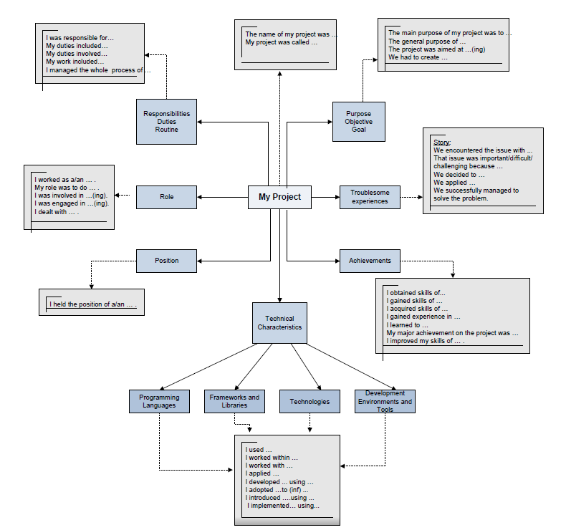
Task 8. Read the text about grants, write out and translate the words given in bold. Learn the words.

WHAT IS A GRAND PROPOSAL?
In short, it’s a request for an investment in a non-profit or for-profit project. It provides a support (usually financial) by a funder (grant-giver) to specific activities, usually following a competitive application process. Unlike a loan, it does not imply expectation of repayment and is governed by specific conditions. Grants are usually offered by governmental organizations, charitable trusts and foundations, non-profit organizations, educational institutions, companies, private individuals. Practically, any person or organization can apply for a grant. The funder usually determines the criteria that must be met in order to receive the funds they intend to award, so the grantee (applicant) needs to carefully evaluate the requirements of a grant before applying.
Thus, grant proposals are to be treated as a project with a defined deliverable or end result for the money sought. Projects must show tangible results or funding will not be granted. A successful grant proposal is one that is carefully prepared, planned, and packaged.
True grants can be very difficult to find and harder still to get. It may not be easy to find the right grant, but when you do, properly completing the grant application will be your biggest challenge. Most grant applications ask for similar information, but they often have different formats. Some will have a list of questions. Others will ask for a ‘narrative’ – the story of your project. Whether it’s for a business or organization, writing a grant proposal is a skill that you can learn.
Task 9. Answer the questions.
- What is a grant?
- Who usually gives grants?
- Who can become a grantee?
- What is a difference between a grant and a loan?
- Is it easy to get a grant?
- What criteria should be met to receive grant funds?
- What is a grant application?
Task 10. Read and translate the text.
HOW TO APPLY FOR A GRANT
The following steps are NOT a strict formula! You must carefully read through the grant application for which you are applying and strictly follow their information and format requirements. However, the following information can usually be adapted to fit the needs of the grant for which you are applying.
Step 1: Background Information
The first step in writing your proposal is to determine why you need a grant. Don’t write a grant unless you have clearly defined why you need the money. Remember grant assistance will not carry a project if it is not based on sound principles. You are doing a great disservice to others by denying them the money if your business idea is not built on sound business and market practices. Secondly, gather information. The information will need to cover three key areas – concept, program and expenses.
- Concept
What is your idea? What is unique about it? What specific problem does this grant address and how does it meet the goals of the funding source? How will it help producers beyond those directly related to the grant project? The need that the proposal is addressing must be documented here. You need to convince your funding source that your need is a compelling one. Collect background data on your organization, statistical information (if any is available) on your idea and the sphere of your interest in general.
- Program
The following checklist covers the program information you will need:
- The nature of the project
- How it will be conducted
- The timetable for the project
- The anticipated outcomes
- Evaluating the results
- Staff, volunteer needs
- Expenses
You will need to have a broad, preliminary budget to show justification for the grant funds. Make sure your costs are in proportion to the outcomes you anticipate.

Step 2: Typical Components of a Proposal.
Be sure to check each grant source carefully for any specific format or content requirements. Study the following table as an example.
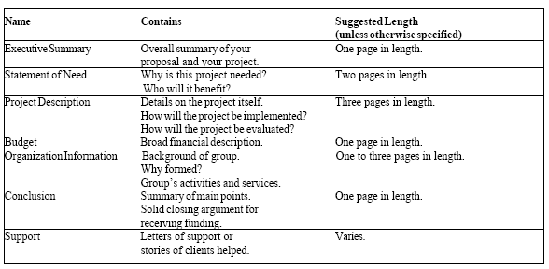
- Executive Summary
This is the most important page of your document. It is on this page that you provide the reader with an overall summary of your project and convince the reader that your project deserves the funding you are asking for. Besuretoincludethefollowing:
- Problem – brief statement about the need for this project.
- Goal– clear and concise statement of the goal(s) of the project
- Solution– a short description of the project including what will take place, how people will benefit from the project, etc.
- Funding requirements– the request for the grant money, how it will be used and how the project will be funded in the future.
- Organization history– a brief statement of the history of the organization, its purpose, activities and the ability to carry out this project.
- Statement of Need
Your statement of need enables your reviewers to learn more about the details of your project and the issues behind it. This section is your opportunity to present your side of the debate. Line up all your arguments and present your case logically and convincingly for the reader. Consider the following points:
- Find current facts or statistics to support your argument.
- Give evidence that your project will be a viable solution to the problem producers are facing.
- Decide if you want to put your project forward as a model or pilot. This could expand your funding options.
- Mention what additional opportunities or benefits might occur for others as a result of this proposal’s success?
- Determine your level of need. Make sure you can support your need and prove that your project is needed more than somebody’s else, or your solution to the problem is better than another person’s.
- Demonstrate that your project addresses the need differently or better than preceding projects. Without being critical of your competition, describe how your project complements and enhances, but does not duplicate, the work of others.
- Be more persuasive and to the point. Discuss what this project would mean to your community, your area and your country in general.

Project Description
This section of your proposal includes the following five sections –objectives, methods, staffing, evaluation and sustainability. Your objectives, combined with your methods, will dictate your staffing needs and will then become a basis for your evaluation. Sustaining the project will come after its success and its ability to survive without a grant source. Together, the five sections give a solid picture of your entire project.
- Objectives must be tangible, specific, measurable and achievable within your specified time frame. Goals are conceptual and show the big picture – objectives are detailed and measurable.
- Methods describe the specific actions you will take to achieve the objectives. It might be helpful to divide your methods into how, when and why.
- Staffing needs to be covered as specifically as possible. How many staff, their qualifications, specific assignments, etc. Describe your plans to administer the project, salary and benefits.
- Evaluation should be built into the project. There are two types of evaluation – one measures the product and another one measures the process. Consider both in this section.
- Sustainability is critical to the proposal reader. You need to demonstrate a how the project will survive long-term and without grant funding. Be specific about current and projected funding streams and the base of financial support for your organization.
Budget
Your budget section is dependent on your project itself. Your proposal may be as simple as a one-page statement of projected expenses, or you may have a complex document of projected support and revenue and various items of expense.
Organization Information
At this point in your proposal, you will want to include a resume for your institution and/or the staff members involved in the project. It is not necessary to overwhelm the reader with pages of facts – the information can easily be conveyed by a brochure or other prepared statement about your project. Explain why your organization came into existence, your mission, your goals and your organizational structure. Discuss your board of directors, if applicable and your activities.
Conclusion
It is important to leave the reader of your proposal with a good feeling about your project and sum up your need for the funding. Call attention to the future – underline some activities that you plan to begin following the funding award or state how you might continue, or not continue, without the funding support.
Make a final appeal for your project. Re-state why your project is important and what you want to accomplish. Why do you need funding to accomplish your goals?
Consideration for Grant Writing:
- Carefully review the grant requirements to ensure you are applying with an appropriate funding source.
- Carefully read and follow all directions and adhere to specific limits on content.
- Develop a plan and timeline for completing the grant application.
- Write clearly and concisely. DO NOT use wordy jargon, abbreviations and acronyms.
- Clearly identify the problem you are addressing.
- Clearly identify the goals and objectives of the proposal for solving the problem.
- Collaborate with others to show support and commitment from other sources to help solve the problem.
- Include appropriate evaluation methods to provide accountability.
- Proof read several times. Have someone unfamiliar with the project read the application for clarity.
- Follow-up. Determine why the application was or was not successful. Identifying the applications strengths and weaknesses will help in your next grant writing effort.

СПИСОК ВИКОРИСТАНОЇ ЛІТЕРАТУРИ

- E.B. Nikolaenko. Business English / Tomsk Polytechnic University Publishing House, 2008, 145 pages
- Stephen Baily. Academic Writing. A handbook for international students. / Fourth edition published 2015byRoutledge2 Park Square, Milton Park, Abingdon, Oxon OX14 4RNandbyRoutledge711 Third Avenue, New York, NY 10017
- Clare Antonia, Wilson J.. SpeakoutPre-Intermediate. Students’ book/ Pearson Longman, Secondedition2016 — 176 pages.
- Яхонтова Т. В. Основи англомовного наукового письма: Навч. посібник для студентів, аспірантів і науковців. - Вид. 2-ге. - Львів: ПАІС, 2003. - 220 с.
- RawdonWyatt. Check Your Vocabulary for Business / A & C Black London PublishersLtd, Soho Square, London W1D 3HB, 1997, 82 pages
- https://www.oxfordonlineenglish.com/airport-english
- www.bbc.co.uk/skillswise
- https://www.passportindex.org/visa.php
- https://www.extension.iastate.edu/AGDM/wholefarm/html/c5-06.html
- https://www.google.com/search?q=business+english&sxsrf=ACYBGNTT06sDVw0joJTdMQG2DRU_iYVH9A:1581090614374&source=lnms&tbm=isch&sa=X&ved=2ahUKEwjGmLXD5b_nAhVdSBUIHdOMCyYQ_AUoAXoECAwQAw&biw=1600&bih=1089#imgrc=v7O0tOdMKQHESM

Інструктивно-методичне видання

Мельник Олеся Дмитрівна
Медведєва Світлана Олександрівна
Гадайчук Наталія Миколаївна

ДІЛОВА АНГЛІЙСЬКА МОВА: ПІДГОТОВКА ДО КОНТРОЛЬНИХ РОБІТ ТА ОРГАНІЗАЦІЯ САМОСТІЙНОЇ РОБОТИ (ЧАСТИНА 2)
Методичні вказівки

Редактор О. Ткачук

Оригінал-макет підготовлено С. Медведєвою

Підписано до друку ............
Формат 29,7×42¼. Папірофсетний.
ГарнітураTimesNewRoman.
Друкрізографічний. Ум. друк. арк. ….
Наклад….пр. Зам. № 2015-

Вінницькийнаціональнийтехнічнийуніверситет,
навчально-методичнийвідділ ВНТУ.
21021, м. Вінниця, Хмельницькешосе, 95.
ВНТУ, к. 2201.
Тел. (0432) 59-87-36.
Свідоцтвосуб’єктавидавничоїсправи
серія ДК № 3516 від 01.07.2009 р.

Віддруковано у Вінницькомунаціональномутехнічномууніверситеті
в комп’ютерномуінформаційно-видавничомуцентрі
21021, м. Вінниця, Хмельницькешосе, 95.
ВНТУ, ГНК, к. 114.
Тел. (0432) 59-87-38,
publish.vntu.edu.ua; email: kivc.vntu@gmail.com.
Свідоцтво суб’єктавидавничоїсправи
серія ДК № 3516 від 01.07.2009 р.

